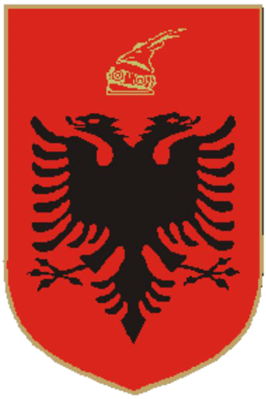
REPUBLIC OF ALBANIA

Deposit Insurance Agency

Annual Report
On the Activity of the Institution in 2024

asd.gov.al

Table of content

Section 1 – About this Report 4
1.1. Message from the Chairman of the Council and the General Director 5
1.2. Executive Summary 9
Section 2 – Resolution of the Assembly of the Republic of Albania 11
Section 3 – Deposit insurance scheme in Albania 27
3.1. Deposits in banks and SCAs 27
3.2. Deposit insurance in banks 28
3.2.1. Eligible deposits in the banking system 28
3.2.1.1. Eligible individual deposits 31
3.2.1.2. Eligible deposits of traders and companies 34
3.2.2. Insured deposits in the banking system 36
3.2.2.1. Insured individual deposits 37
3.2.2.2. Insured deposits of traders and companies 38
3.3.1. Eligible deposits in SCAs 40
Section 4 – Administration of funds and financial sources of the ADIA 44
4.1. Deposit insurance fund in banks 44
4.1.1. Performance of the deposit insurance fund in banks 44
4.1.2. Key financial indicators of the deposit insurance fund in banks 44
4.1.3. Coverage ratio of insured deposits in banks 46
4.2. Deposit insurance fund in SCAs 47
4.2.1. Performance of the deposit insurance fund in SCAs 47
4.2.2. Key financial indicators of the deposit insurance fund in SCAs 47
4.2.3. Coverage ratio of insured deposits in SCAs 49
4.3. Administration of financial assets 49
Section 5 – Strategic Plan 2024-2026 and activities for 2024 52
5.1. Strategic Plan 2024-2026 52
5.2. Public awareness and financial education activities 54
5.2.1. Participation in financial education activities 54
5.2.2. Open lectures 55
5.2.3. Promotion of the scheme by informing depositors in bank branches 56
5.3. Activities at international level 56
5.3.1. Contribution at international forums 56
5.3.2. Cooperation with the Hungarian Deposit Insurance Fund 57
5.3.3. Cooperation with the Kosovo Deposit Insurance Fund 58
Section 6 – Good governance of the organisation 60
6.1. Governing Council 60
6.2. Organizational structure 61
Section 8 – Resolution Fund 64
8.1. Administration of the Resolution Fund 64

Section 1 – About this Report
The Annual Report 2024 provides an overview of the financial and administrative activity of the Deposit Insurance Agency for the period from January 1, 2024 to December 31, 2024. This Report was drafted based on Law No. 53/2014, dated May 22, 2014, “On Deposit Insurance”, as amended by Law No. 39/2016 and Law No. 132/2016, the Annual and Periodic Monitoring Manual approved by Decision of the Assembly of the Republic of Albania No. 134/2018, dated 20/12/2018, the Resolution of the Assembly of Albania “For the Assessment of the Activity of the Deposit Insurance Agency in 2022”, as well as laws and by-laws that regulate the activity of the Agency.
The financial statements reflect the financial position of the Agency as of December 31, 2024, as well as its performance and cash flow for the year ended on this date. The statements have been prepared in accordance with Law No. 25/2018, dated 10/05/2018, “On Accounting and Financial Statements”, as amended, and the International Financial Reporting Standards (“IFRS”). According to Law No. 53/2014, dated May 22, 2014, “On Deposit Insurance”, as amended, the annual financial statements of the Agency are audited and certified by authorized external auditors.
The annual report and financial statements have been approved by the Governing Council of the Deposit Insurance Agency. The Governing Council has exercised its powers conferred by law to ensure that the annual report and financial statements fairly represent, in all material respects, the performance and administration of the Deposit Insurance Agency throughout the reporting year.
You are kindly requested to provide your comments on the Annual Report 2024 at info@asd.gov.al. This Annual Report, as well as previous annual reports, can be found on our official website www.asd.gov.al.

Message from the Chairman of the Council and the General Director
Dear readers,
We are pleased to present to you, as every year, the Annual Report of our institution for 2024. This year as well, developments have been positive for the Albanian economy and the banking sector in particular, reflecting our joint efforts to guarantee financial stability and protect depositors.
As a result, the Albanian economy has recorded stable growth, generating more employment, higher wages, and increased income for families and businesses. Inflation has remained low and under control, reaching a level of 2.2%, which has eased the burden of costs for citizens and has created a financial environment conducive to economic development.
In parallel, the banking sector has shown stability and improving financial indicators. The ratio of non-performing loans has decreased significantly over the last 10 years, from almost 23% to 4.2%, reflecting a marked improvement in the quality of the loan portfolio. The capital adequacy ratio has marked an average level of 18%, indicating the strengthening of the financial capacities of the banking sector. Banks have continued to lend to the economy, maintaining a high level of liquidity and profitability, further strengthening public confidence.
Deposits in the banking system have marked an increase of 4.9%, or ALL 78.2 billion more than in 2023, and the number of insured depositors has had an annual increase of about 144,000 depositors, causing the deposit insurance fund to increase by 10.3%, also as a result of the increase in income from the investment activity by 20.74%, which reflects public confidence in the banking system.

In this positive context, the Deposit Insurance Agency has continued to implement its strategic priorities with dedication and efficiency, strengthening its institutional and operational capacities in view of fulfilling its legal mandate.
During 2024, based on the recommendations of the Albanian Assembly and the instructions of the management structures, the Agency has improved its technical infrastructure and human capacities, investing in staff training and technology to guarantee a rapid and efficient response in the event of a compensation event. As per the above, intensive work has been done to improve the supervision and risk analysis capacities through technical simulation exercises and verifications, as well as continuous constructive interaction with banks and Savings and Credit Associations, thus strengthening the mechanisms for protecting depositors.
We have also paid attention to continuous information and increasing financial education among stakeholders. The relevant structures of the Agency participated in and contributed to financial education activities organized by the Bank of Albania and the Albanian Association of Banks. In addition, considering that bank branch employees have an essential role in informing depositors, we have engaged in regular regional meetings with them, aiming to increase the level of awareness on the importance of accurately informing depositors on the deposit insurance scheme and its features.
One of the main initiatives has been the drafting and approval of the Strategic Plan 2024–2026, which sets out the strategic directions that the Agency will follow in the medium term. In drafting this plan, we have carefully considered the achievement of the objectives of the previous plan and have based ourselves on the public objectives of the deposit insurance scheme, which are the foundation of our activity.

The strategic priorities of the Agency for the three-year period 2024–2026 are as follows:
- To increase and strengthen the operational, financial, regulatory, human, and infrastructural capacities in order to meet its institutional objectives.
- To guarantee effective communication with stakeholders through interaction with scheme members and other identified stakeholders.
- To continue harmonization with European legislation within the framework of the National Program for EU Integration.
By focusing on these three strategic directions, we are confident that the activities and initiatives set out will enable us to effectively fulfil our legal mandate.
We would also like to emphasize the importance of inter-institutional cooperation with the Bank of Albania, the Ministry of Finance, the Albanian Association of Banks, and the members of the deposit insurance scheme (banks and Savings and Credit Associations) for the successful implementation of the strategic priorities of the Agency. Within the framework of this Strategic Plan, the Agency is committed to increasing the level of its operational capacities in order to effectively prepare for a compensation event, as well as to inform and raise public awareness about the benefits of the deposit insurance.
Considering that the official process of negotiations for membership in the European Union began in 2024, the Agency has taken the necessary steps to be in line with the commitments of the Albanian Government in this regard. As set out in the medium-term strategy, in consultation with international partners and coordination with Albanian regulatory authorities, we have begun work to address issues that will bring us closer to EU legislation on deposit insurance.

Being aware of the regulatory, legislative, and institutional challenges, we are confident that the capacity of the Agency's structures and cooperation with the Assembly of Albania, the Bank of Albania, the Ministry of Finance, and the members of the deposit insurance scheme are a guarantee to fulfil this institutional commitment within the parameters set by the Albanian Government.
In conclusion, based on the foregoing as well as our projections, we reaffirm our belief that the Albanian financial system will remain safe for depositors due to the strong supervision, the legislative and regulatory measures of financial institutions, and the careful risk management by the members of the deposit insurance scheme.
Thank you,
Donald Duraj Genci Mamani
Chairman of the Governing Council General Director

  - Executive Summary
In 2024, the Deposit Insurance Agency insured deposits placed by depositors in 11 banks and 9 Savings and Credit Associations (SCAs).
The total deposits in the banking system at the end of 2024 were ALL 1,683 billion, with an annual increase of 4.9%. The Agency's liability for compensation at the end of that year was ALL 921 billion for 1,986,871 bank depositors. At the end of 2024, the value of the eligible deposits benefiting from the deposit insurance scheme reached ALL 1,590.2 billion, representing 94.5% of the total deposits. Compared to the previous year these deposits increased by 5.2%, while their increase in absolute value was ALL 78.9 billion. At the end of 2024, the eligible deposits in Euro expressed in their equivalent value in ALL occupied the largest share of the total eligible deposits with 47.4%, followed by deposits in ALL with a share of 46.9%, and deposits in USD with their equivalent in ALL at 4.1%. Eligible individual deposits in the banking system at the end of 2024 reached ALL 1,275.4 billion, representing 80.2% of the total eligible deposits. At the end of 2024, the insured deposits in the banking system were 54.7% of the total deposits in the banking system, and 57.9% of the eligible deposits. 92.9% of depositors in banks are fully compensated.
The total deposits in SCAs at the end of 2024 were ALL 11.5 billion, up from ALL 10.9 billion in December 2023. The eligible deposits were ALL 11.3 billion and accounted for 98.4% of the total deposits, compared to ALL 10.8 billion the previous year. At the end of 2024, these deposits corresponded to 44,270 depositors in SCAs. The eligible deposits increased by 4.8% during 2024. The main impact on this increase was from the increase in ALL deposits. Deposits in ALL accounted for the largest share of the total eligible deposits in SCAs, at 77.2%. Their annual increase was 5.4%. At the end of 2024, the insured deposits in SCAs were ALL 8.1 billion, which is 70% of the total deposits, or 71% of the eligible deposits. 91% of depositors in SCAs are fully compensated.

The deposit insurance funds in banks and Savings and Credit Associations have had a steady growth throughout 2024. The main income contributing to the growth of these funds is the income from insurance premiums and the income from the management of the financial assets. On December 31, 2024, the book value of the deposit insurance fund in banks was ALL 70.1 billion. Compared to the previous year, this fund has increased by about ALL 6.5 billion, or 10.3%. The income from the insurance premiums paid by banks for 2024 was ALL 4.39 billion, or 5.4% higher than in 2023. The income from the management of the financial assets of the deposit insurance fund in banks for 2024 was ALL 2.83 billion or 20.7% more than the previous year. The increase in income for 2024 is related to the expansion of the financial assets under administration and the interest rates on securities. At the end of 2024, the coverage ratio, calculated as a percentage of the deposit insurance fund in banks versus insured deposits, was 7.61%.
At the end of 2024, the book value of the deposit insurance fund in SCAs was about ALL 256.9 million, marking an increase of 15.3% compared to 2023. The income from insurance premiums for 2024 was ALL 23.49 million, which compared to 2023, has increased by 6.22%. The income from the administration of the financial assets of the deposit insurance fund in SCAs during 2024 amounted to ALL 10.95 million, which compared to 2023, has increased by 22.71%. At the end of 2024, the coverage ratio, calculated as a percentage of the deposit insurance fund in SCAs versus insured deposits, was 3.19%.
Throughout 2024, the Agency has exercised its legal duty for the administration of the Resolution Fund in compliance with the acts approved by the Resolution Authority at the Bank of Albania. The annual contribution paid by the banks for 2024 was ALL 982.1 million. As of December 31, 2024, the book value of the net assets available to the Resolution Authority was ALL 5.73 billion.

Section 2 – Resolution of the Assembly of the Republic of Albania
The Resolution of the Assembly of the Republic of Albania defines the directions on which the Agency should focus to improve certain aspects of its activity. To this end, the recommendations of the Resolution of the Assembly are an essential part of planning the strategic objectives of the institution and, therefore, they are at the focus of all its structures. Following, all the actions undertaken by the Agency to address the recommendations of the Assembly of the Republic of Albania, which are considered to have been successfully fulfilled, are presented in detail.
Recommendation | To intensify work towards ensuring institutional readiness for the effective compensation of depositors through testing, technical simulations, and cooperation with banks and SCAs members of the scheme.
Actions taken by the ADIA | 1. Technical simulations  During 2024, the Agency has continued to conduct technical simulations with member entities of the deposit insurance scheme, banks and Savings and Credit Associations, for the accurate reporting and uploading to the Agency's system of simulation/compensation files for the single customer view of depositors from banks and SCAs.  While conducting technical simulations with the member entities, the Agency, through verifications carried out by its Reporting and Compensation Information System assessed the accuracy of the files for the single customer view of depositors in the event of an insurance event, or for simulation purposes. These technical simulations were also part of verifications carried out by the ADIA in member entities of the deposit insurance scheme, specifically to verify the readiness to report simulation/compensation files, as well as the accuracy of the data of depositors, who will be compensated in the event of a compulsory liquidation of a member entity of the scheme. In cases of inaccuracies identified from these simulations, the ADIA cooperated with the responsible staff of the entities to correct the identified findings until the uploading of the files resulted in success. At the end of the verification process, the Agency sent a verification report, part of which are also the recommendations for the work to follow.  2. Selection of the agent banks to carry out the payment process in case of an insurance event.      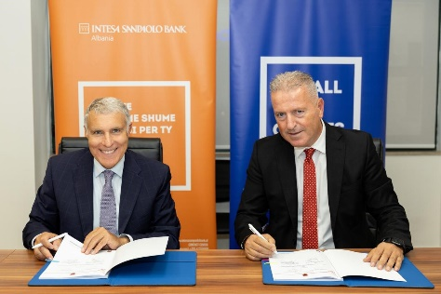    Based on laws and by-laws that regulate the activity of the ADIA, the compensation process will be carried out through one or several banks selected from the banking system, which are considered agent banks. Their role in the process is related to making payments to insured depositors in accordance with the payment list and funds sent by the ADIA. Therefore, the selection of these banks is of crucial importance for an effective compensation process.  Based on the legal and regulatory provisions, the ADIA undertook the process of selecting agent banks for the period 2024–2026. The process, which went through several stages and included cooperation with both the Bank of Albania and member banks of the deposit insurance scheme that expressed their interest in performing this role, was finalized with the selection of four agent banks. The Governing Council, with its Decision no. 18, dated 30/07/2024, selected OTP Bank Albania sh.a, the National Commercial Bank sh.a, Intesa Sanpaolo Albania Bank sh.a., and Credins Bank sh.a. as agent banks on the preliminary list. Subsequently, in September 2024, contracts for the provision of the insured deposit compensation service were signed between the ADIA and the selected agent banks.  Following the selection on the preliminary list, agent banks will be part of simulation exercises, as well as special training to successfully carry out a payment process for the compensation of depositors.  3. Meetings with scheme member entities  The Agency, following its continuous cooperation with the members of the deposit insurance scheme and aiming to successfully fulfil its mandate for the efficient compensation of depositors and preservation of financial stability, conducted several regional meetings with managers and employees of bank branches and SCAs in Fier, Berat, Lushnjë, Gjirokastër, Saranda, Shkodër, Lezhë, Korçë, Pogradec, Bilisht, and Ersekë. This planned geographical distribution aimed at contacting employees of bank branches and SCAs in practically all urban centres where it is estimated that the largest number of branches of financial institutions participating in the deposit insurance scheme is situated. The purpose of the meetings and topics covered were related to raising awareness among employees of banks and SCAs about their important role in the proper functioning of the deposit insurance scheme, being well-informed about the features of the scheme, and informing depositors on the benefits and limitations stemming from the deposit insurance scheme. The meetings emphasized the role of bank employees in everyday activity for the complete and accurate insertion of data on depositors and deposits, as well as the standardization of data maintenance for eligible deposits; the single customer view of depositors (SCV); technical simulations and accurate information of depositors on deposit insurance and compensation. Special attention was paid to the role of the agent bank employees for prompt and accurate completion of the compensation payment process in case of an insurance event, as well as accurately informing depositors about the deposit compensation process.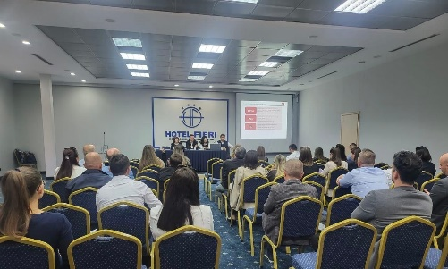
Status | Achieved
Recommendation | To contribute to the advancement of the deposit insurance scheme by aligning the regulatory framework with European deposit insurance schemes by 2024, and addressing issues that are not in compliance with Directive 2014/49/EU “On Deposit Guarantee Schemes”.
Actions taken by the ADIA | 1. Changes to the ADIA’s regulatory framework.  The Governor of the Bank of Albania, with Decision No. 2680, dated 20/06/2024, approved additions and amendments to Regulation No. 3762, dated 18/7/2016, “On Insured Deposit Compensation”, proposed by the Governing Council of the Deposit Insurance Agency. Reviewing this by-law is part of priorities set out in the Strategic Plan for 2024. The approved additions and amendments improve the degree of approximation of the domestic regulatory framework to Directive 2014/49/EU “On Deposit Guarantee Schemes”, and compliance with international standards in the deposit insurance field. To this end, the ADIA received technical assistance from the World Bank's FinSAC, and reviewed the provisions in force through a transparent process in cooperation with the Bank of Albania, representatives of the member banks of the deposit insurance scheme, and agent banks. One of the most significant changes adopted by this regulation, which addresses one of the most fundamental issues that constitute inconsistencies with the EU directive, is the shortening of the deadline for initiating the payment process for deposit compensation from “within 20 (twenty) business days” to “within 14 (fourteen) business days”. This change comes as a result of improved operational and financial capacities of the Agency to fulfil its legal function for deposit compensation, through:  - the Agency's access to liquidity through the repurchase agreement signed with the Bank of Albania;  - the operationalization of the borrowing process through the agreement “On the use of public financial support for the resolution and compensation of deposits to preserve financial stability”, drafted and signed in 2024 by the Ministry of Finance, the Bank of Albania, and the Deposit Insurance Agency;  - improvements made to the information technology infrastructure; and  - experience from simulation exercises conducted over the years.  2. Project with the EBRD to design a risk-based premium payment methodology.  Within the framework of the Albanian Government's strategic program for EU integration, the Agency has started work on addressing issues that constitute non-compliance with Directive 2014/49/EU “On Deposit Guarantee Schemes”. One of the main issues is related to the application of the risk-based premium for member entities of the deposit insurance scheme. In this regard, the Agency, with the assistance of the EBRD, has completed a project for the development of a methodology for the calculation of the risk-based premium. The purpose of the methodology is the application of differentiated premiums for member entities of the deposit insurance scheme, in accordance with the risk they carry. The calculation method was developed based on recently revised guidelines by the EBA (European Banking Authority) for this purpose. The risk-based premium and the calculation methodology according to European definitions constitute essential elements of the legal changes aimed at increasing the compliance of the deposit insurance scheme with Directive 2014/49/EU “On Deposit Guarantee Schemes”.  3. Update with expected changes to Directive 2014/49/EU “On Deposit Guarantee Schemes”.  The harmonization of the Albanian deposit insurance legislation with the EU acquis is one of the strategic priorities of the Deposit Insurance Agency. As a public institution, the ADIA is part of the EU accession process, and is included in Chapter 9 “Financial Services”, alongside the Bank of Albania and the Financial Supervisory Authority. This process is mainly related to the compliance of the regulatory framework on deposit insurance with Directive 2014/49/EU “On Deposit Guarantee Schemes”. Taking into account the above, the ADIA has continued its efforts to address issues that constitute inconsistencies with EU directives. However, the ADIA’s efforts are also influenced by developments in the EU regulatory environment. The key development in this regard is related to the legal reform undertaken by the European Commission with the aim of strengthening and improving the legal framework for financial crisis management and deposit insurance schemes. The reform is expected to bring substantial changes to Directive 2014/49/EU “On Deposit Guarantee Schemes” and Directive 2014/59/EU “On Recovery and Resolution of Financial Institutions”. The European Commission’s draft proposals to amend the legal framework for deposit insurance and resolution seek to preserve financial stability and taxpayer income, protect the economy from the impact of banking institutions bankruptcy, and provide more efficient protection for depositors.  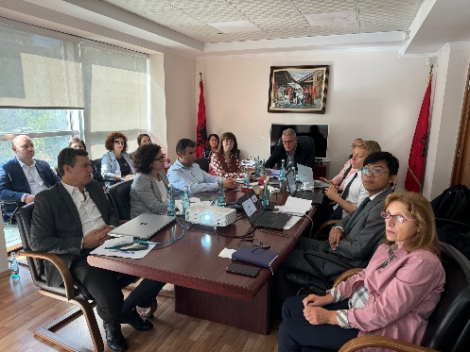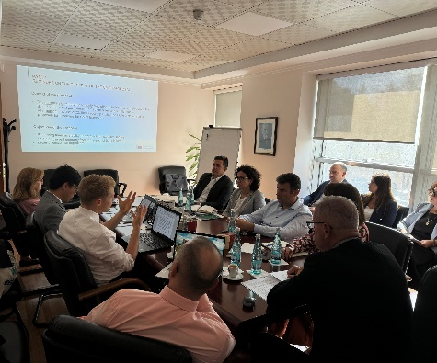Given the impact and significance of these changes for the continuation of the compliance process, the ADIA, in cooperation with the World Bank’s FinSAC office, organized an information meeting with experts from the Directorate-General for Financial Stability, Financial Services and Capital Markets Union (DG FISMA), which is the European Commission department in charge of EU financial services policies. The representative of DG FISMA provided an overview of the context in which the expected changes to the EU legal framework for financial crisis management and deposit insurance schemes have been proposed. The meeting also focused on the suitability of these changes and their compatibility with the legal and regulatory framework for deposit insurance and resolution in the Republic of Albania. The meeting with DG FISMA was deemed important to provide an update on the anticipated changes to the EU Directives, with the goal of undertaking coordinated legal initiatives towards drafting a comprehensive legal package that is consistent with the legal framework of the European Union.  4. A project with the World Bank’s FinSAC office to provide technical assistance in coordinating all prior projects and drafting a legal package to address issues of non-compliance with EU Directives.  As part of the process of legal and regulatory approximation with the EU framework, the ADIA has constantly conducted technical assistance projects with partner international financial institutions. Based on analyses conducted within the framework of these projects, the Agency has identified the key issues where full harmonisation with Directive 2014/49/EU “On Deposit Insurance Schemes” has yet to be achieved. These include the coverage level of insured deposits, the adoption of a risk-based premium collection model, the coverage of certain categories of depositors, the definition of a target fund level, the payment period, and provisions for temporary high balances. Following this preliminary work, and taking into account the commitments of the Albanian Government within the framework of the National Plan for EU Integration 2025–2027, the ADIA aims to carry out a comprehensive project in cooperation with the FinSAC experts. The project will coordinate the results of all previous technical assistance projects, as well as analyze in detail the Law No. 53/2014, dated 22/05/2014, “On Deposit Insurance”, as amended by Directive 2014/49/EU “On Deposit Guarantee Schemes”, with the aim of drafting a complete legal package, which, prior to being submitted for approval to the Albanian Assembly, will be subject to consultation and agreement with regulatory authorities and financial system stakeholders in the country. Currently, the ADIA and the World Bank’s FinSAC office have defined the modalities and terms of reference of the project, aiming to fulfil the commitments undertaken by the Agency within the framework of the National Plan for EU Integration 2025–2027.
Status | Achieved
Recommendation | To increase transparency through the publication of statistical data and reports in formats and platforms easily usable by the general public.
Actions taken by the ADIA | The Agency has constantly worked for and assessed the quality of information that serves and interests the general public. In order to implement the recommendations of the Assembly as well as the ADIA’s Strategic Plan 2024–2026, the Agency has increased its efforts towards transparent communication with the public.  One of the main initiatives carried out by the ADIA this year, in terms of informing the public as simply and transparently as possible, was the redesigning of the Agency's official website. The redesign has visually ensured a more user-friendly approach to the website, adapted to contemporary technology in terms of network security. The redesigned website now offers a clear structure, in which information that is considered essential for informing depositors is easily consultable. A new feature that contributes to easier access by the public is the availability of the website on mobile devices, such as mobile phones or tablets.  In this regard, and taking into account the recommendations of the Assembly, the redesigned website structure provides more extensive information, increasing the range of data and statistics published. For this purpose, specific menus and sections have been created for the publication of data and reports on deposit performance in general as well as for specific categories according to the ADIA’s classifications. Interested parties can now find, under the “Statistics” menu on the ADIA’s website, information concerning the performance of deposits in the banking system/SCAs by insurance categories, the number and percentage of depositors in the banking system/SCAs that are fully and partially compensated, as well as the coverage ratio of insured deposits in banks/SCAs covered by the deposit insurance fund. The data is presented in a format that is easily understandable by all interested parties. In order to ensure transparency with the public and guarantee quick access to key ADIA’s data, a new section “Open Data” has been added to the official website, which provides quick access to comprehensive information on the ADIA’s activity, such as annual reports, strategic plans, etc.
Status | Achieved

Recommendation | To cooperate with the Bank of Albania and other parties involved in the process to identify and manage cyber risks.
Actions taken by the ADIA | - Establishing the second functional centre for the Agency's central IT systems in cooperation with the Bank of Albania, and improvements to the ADIA's technological infrastructure.  In the context of increasing the response capabilities in cases of emergency situations, including cyber incidents, in 2024 the Agency implemented a project for the establishment of a second functional centre for the Agency's central IT systems, which will ensure the continuation of work in any case.  For this purpose, the Agency and the Bank of Albania signed a loan-use contract for the use of premises within the Berat Research Centre building, owned by the Bank of Albania. The Agency carried out the necessary improvements to the premises as specified in the contract, according to the appropriate standards for Information Technology facilities. This environment houses the equipment required to restore the Agency's primary IT systems to normal operation in the event of a failure, major event, or cyber incident.  The installation of equipment and services at the centre ensures that the institution's critical functions will continue to be available in each of their components despite serious incidents or damage that could interrupt services, and that they will be restored to operational condition within a short period of time.  - Preventive measures to avoid cyber threats.  As part of its measures to increase security against cyber attacks, the Agency created a platform for collecting and analyzing logs from information security systems. To protect and preserve critical data and its information systems, the Agency's technological infrastructure implements functional security systems for perimeter network protection, end and remote users protection, e-mail service protection, load management, and application security. These systems generate and store logs locally in their storage spaces, and the platform serves as a unified and centralized system for their management and analysis. The platform provides a clear and updated view of network traffic, enabling preventive measures to be taken to avoid potential cyber threats or incidents. During this time, the platform identified faults and other suspicious events in the network, and the IT staff managed alerts, which increased the safety of the Agency’s network, applications, database, and servers.  - Audit by the National Cyber ​​Security Authority (NCSA).  In order to increase the level of cyber security, in July 2024, the Agency identified and analyzed cyber security risks with the assistance and supervision of the NCSA. Following that, the required cyber security measures that the Agency should implement to improve its current infrastructure were determined.  The Agency is committed to implementing the measures recommended by the NCSA, which are deemed to help us address the identified issues, thus increasing the ADIA’s level of security against cyber risks. Throughout this year, the Agency's IT staff has participated in NCSA trainings aimed at increasing their awareness and practical skills in providing the essential security against current attacks in the country and region.  - Meetings with member entities of the deposit insurance scheme on cyber security.  - In view of the implementation of the Resolution of the Albanian Assembly and considering that addressing cyber risks in the financial sector is a challenge that requires unified efforts from all institutions involved, the Agency, in cooperation with the Albanian Association of Banks, organized an awareness-raising meeting on the importance of cyber security in the financial system.    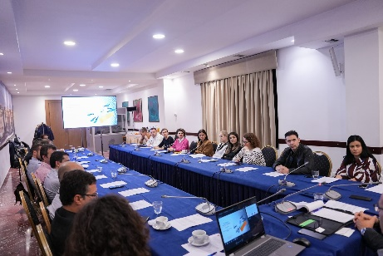  Representatives of the Bank of Albania and all banks of the banking system in the country attended the activity. The primary goal of the meeting was to address common challenges in identifying and mitigating risks from cyber threats. The discussions focused on maintaining public trust in the financial system, by improving data security and protecting depositor information. A high-level cyber security expert from the United States Department of the Treasury was invited to the meeting to share the best experiences for effectively addressing cyber risks. He provided a broad overview of cyber risks, international regulatory standards, and ways in which the Deposit Insurance Agency, in cooperation with the Bank of Albania and member banks of the deposit insurance scheme, may contribute to strengthening the security of deposit-related information. Participants shared experiences and best practices in addressing cyber risks and discussed the most efficient ways of cooperation to ensure strong protection against potential cyber attacks. This meeting was an important step towards raising awareness and strengthening capacities in facing cyber challenges, actively contributing to a safer and more sustainable financial system. Following the meeting, the Agency became part of the MISP platform, which is managed by the Albanian Banking Association and includes the Bank of Albania and member banks of the deposit insurance scheme. MISP platform serves to identify and report cyber threats in the banking sector.  - Also, in the context of continuous awareness about information security and prevention of cyber incidents, the Agency included the importance of strengthening our joint commitment to cyber security and safeguarding the digital infrastructure as part of the topics for discussion in regional meetings with banks and SCAs. The presentations provided to the audience and subsequent discussions further emphasized the attention and care to be shown to various cyber threats, given the necessity of remaining vigilant and proactive in preserving information security against these malicious threats.
Status | Achieved

Recommendation | To cooperate with the Bank of Albania to harmonize interaction practices in the view of the resolution.
Actions taken by the ADIA | - Meeting with the Resolution Department at the Bank of Albania and experts from the World Bank's FinSAC office.  In the framework of this recommendation of the Assembly, the ADIA initiated and organized, in cooperation with the Bank of Albania, a working meeting aimed at increasing the effectiveness of the institutional interaction between the Resolution Department of the Bank of Albania and the ADIA in cases of resolution financing.      The meeting analyzed on a technical level the possible scenarios for the Agency' participation through the transfer of the deposit compensation fund to banks in the event of resolution, as well as the expected proposals within the framework of the European Union regulatory framework reform for financial crisis management. The FinSAC experts shared their experiences and best practices, focusing on the interaction among institutions for crisis management and resolution. The authorities who participated in the meeting discussed the most efficient ways of cooperation and interaction between the Deposit Insurance Agency and the Bank of Albania to maintain public confidence in a safe and stable financial system.  2. Meeting with DG FISMA to provide an update on the expected changes to Directive 2014/59/EU “On Recovery and Resolution of Financial Institutions”.  The legal reform proposed by the European Commission to strengthen and improve the legal framework for financial crisis management and deposit insurance schemes is largely related to the resolution mechanisms. Taking this fact into account, the ADIA invited representatives of the Resolution Department at the Bank of Albania in a meeting organized with representatives from the Directorate-General for Financial Stability, Financial Services and Capital Markets Union (DG FISMA). The meeting provided a platform for discussions on the suitability and adoption of the legal amendments to the EU legal framework in national legislation, as well as institutional interaction in cases of the employment of the resolution instruments.
Status | Achieved

Section 3 – Deposit insurance scheme in Albania

3.1. Deposits in banks and SCAs
In 2024, the Deposit Insurance Agency insured individual deposits in 11 banks of the system, as well as in 9 Savings and Credit Associations. At the end of 2024, the total deposits in the banking system were ALL 1,683 billion, and the total deposits in Savings and Credit Associations were ALL 11.5 billion.
Total deposits in banks and SCAs for 2024

According to data from the end of 2024, the Agency had the liability to compensate ALL 921 billion deposits in banks, or 1,986,871 depositors, as well as the liability to compensate ALL 8.1 billion deposits in Savings and Credit Associations, or 22,205 depositors. Of the total liabilities of the Agency of ALL 929.1 billion to depositors who have placed their deposits in banks and SCAs, 99.1% is the Agency's liability to depositors who have placed their deposits in banks, and 0.9% is the Agency's liability to depositors who have placed their deposits in Savings and Credit Associations. The Agency fully compensates 92.9% of depositors in banks and 91% of depositors in SCAs.
Depositors in any bank are insured to the extent of 100%, but in any case no more than ALL 2,500,000 (two million five hundred thousand), while depositors in Savings and Credit Associations are insured to the extent of 100%, but in any case no more than ALL 2,000,000 (two million), regardless of the number of deposits or the type of their currency.

3.2. Deposit insurance in banks
In 2024, the total deposits in the banking system had a positive performance. Compared to the previous year these deposits increased by 4.9%, which corresponds to an increase in absolute value of ALL 78.2 billion.
Dynamics of deposits in the banking system by the end of 2002-2024

3.2.1. Eligible deposits in the banking system
By the end of 2024, the value of the eligible deposits benefiting from the deposit insurance scheme reached ALL 1,590.2 billion, representing 94.5% of the total deposits. Compared to the previous year these deposits increased by 5.2%, while their increase in absolute value was ALL 78.9 billion. Eligible deposits include time deposits, current accounts, savings accounts, card accounts, joint accounts, and other similar products.
By the end of December 2024, the eligible deposits in Euro expressed in their counter value in ALL accounted for the largest share of the total eligible deposits at 47.4%, followed by deposits in ALL at 46.9%, and deposits in USD with their counter value in ALL at 4.1%.

Structure of the amount of eligible deposits in the system by currency

The dynamics the of eligible deposits in ALL during 2024 has been positive in eight months of this period, but the monthly change rates have been relatively small, while a relatively slight decrease was observed in the months of February, March, April, and August. The highest positive monthly change rate was recorded at the end of December, with +2.8%. In this period, these deposits reached a value of ALL 745.9 billion.
Eligible deposits in foreign currency in December 2024 constituted 53.1% of the total eligible deposits and their equivalent in ALL was ALL 844 billion. A positive monthly change rate for deposits in foreign currency converted into ALL was recorded during seven months of the year, while a relatively slight decrease was observed in the months of February, March, April, June, and October. The largest increase of 2.9% was recorded at the end of August, which came as a result of the increase in deposits in Euro, where their monthly increase in original currency was 3.8%, while their counter value in ALL marked an increase of 3.2%.

Dynamics of the eligible deposits in the system by currency 2014 - 2024

By the end of December 2024, the eligible deposits less than or equal to the maximum coverage level were ALL 567.83 billion (36% of the total amount of eligible deposits), while deposits above the maximum coverage level reached ALL 1,022.3 billion (or 64% of the total amount of eligible deposits).
Structure of the eligible deposits compared to the coverage level ALL 2.5 bn

3.2.1.1. Eligible individual deposits
As of December 31, 2024, these deposits in the banking system reached ALL 1,275.4 billion, and constituted the largest part of the total eligible deposits, specifically 80.2% of them (the annual change rate was +5.6%). The largest share of the eligible individual deposits is occupied by deposits in ALL with 48.6%, followed by deposits in Euro with 45.8%. During 2024, the performance of the individual deposits in ALL has been positive almost throughout the period, with a slight decrease recorded in the months of January and August. The monthly change rates have been relatively low, and the largest increase was recorded in February, with 0.9%. The largest impact on the annual growth of 5.6% of the eligible individual deposits was provided by deposits in ALL, which recorded an annual increase of 7.3%. In December 2024, deposits in foreign currency expressed in their counter value in ALL had a share of 51.4%, and their annual growth was 3.9%. In this period, deposits in Euro expressed in their counter value in ALL reached the amount of ALL 584.6 billion, marking an annual growth of ALL 23 billion (+4.1%), while in original currency they increased by 10.2%. These deposits accounted for the largest share of the individual deposits in foreign currency. During 2024, the performance of the individual deposits in Euro has been positive throughout the period, while expressed in their counter value in ALL they have shown both positive and negative trends, as a result of the trend of the ALL exchange rate against Euro. The largest monthly growth was recorded in August with 2.2%, while expressed in their counter value in ALL they increased by 1.6%.
Individual deposits in original currency in USD, compared to the end of 2023, increased by 4.6%, while expressed in their counter value in ALL (with a share of 3.7%) they marked an annual increase of 4.9 %.

Structure of the amount of eligible individual deposits in the system by currency

In 2024, the performance of the eligible individual deposits up to the coverage level has been almost positive. By the end of 2024, deposits with amounts up to ALL 2.5 million had a share of 42% against the total eligible individual deposits, and compared to the end of 2023, they marked an annual increase of 5.2%. Whereas deposits with amounts above the coverage level, compared to the end of 2023, have increased in absolute value by about ALL 41 billion (or 5.9%), contributing to an annual increase of 5.6% of the eligible individual deposits.
At the end of 2024, the number of individual depositors insured by the deposit insurance scheme in the banking system was 2,787,539. This number also includes depositors with a balance of ALL 0 to 100 (the legal minimum for compensation), who in December 2024 were 949,969.
Among individual depositors with deposits greater than ALL 100, 93.1% of them or 1,711,695 depositors have deposits up to the coverage level and benefit from full coverage from the deposit insurance scheme. The amount of deposits corresponding to these depositors reached ALL 535.9 billion. By the end of December 2024, the individual depositors with deposits greater than ALL 2.5 million were 125,875, and the amount of their deposits reached a value of ALL 739.5 billion.
Dynamics of the number of individual depositors classified by level of coverage 2014-2024

Dynamics of the number of individual depositors classified by level of coverage 2014-2024 in %

For the period 2014–2024, the percentage of individual deposits valued at up to ALL 2.5 million varied from 40% to 44% of the total eligible deposits.
Dynamics of individual deposits classified by level of coverage 2014-2024 in %

3.2.1.2. Eligible deposits of traders and companies
In December 2024, these deposits in the banking system reached ALL 314.8 billion, increasing by 3.8% during the year. Deposits with amounts up to ALL 2.5 million increased by 9.9%, and their share of the total eligible deposits of traders and companies was 10.2%, while deposits with amounts over ALL 2.5 million (with a share of 89.8%) increased by 3.2%.
By currency type, deposits in Euros expressed in their counter value in ALL accounted for the largest share of deposits of traders and companies of 53.9%, and marked an annual increase of 4.9%, while in their original currency they increased by 11%. In 2024, deposits in original currency in Euro had a positive monthly change only in the months of April, July, August, and September, and their largest increase was recorded in August with 9.4%. Deposits in ALL accounted for 39.9%, and recorded an annual increase of 6.6%, giving the greatest impact on the annual growth of the eligible deposits of traders and companies. Deposits in USD expressed in their equivalent in ALL accounted for 5.6%, and recorded an annual decline of -17.2%.

Structure of the amount of eligible deposits of traders and companies by currency

By product category, the largest share of the eligible deposits for traders and companies was occupied by current accounts with 88%.

Structure of the amount of eligible deposits of traders & companies by products

Unlike the situation of the eligible individual deposits, 89.8% of deposits of traders and companies are in amounts above the coverage level, and correspond to 15,435 depositors, who represent 8.1% of traders and companies. In December 2024, the share of this category of depositors (with deposits greater than ALL 2.5 million), both in number and amount, was almost the same as at the end of 2023.

3.2.2. Insured deposits in the banking system
At the end of 2024, the insured deposits in the banking system reached ALL 921.1 billion. The insured deposits constituted 54.7% of the total deposits in the banking system and 57.9% of the eligible deposits.
Dynamics of insured deposits versus total deposits and eligible deposits – 2014–2024

The annual growth of the insured deposits from 2023 to 2024 was 5.4%. Meanwhile, for the last 10 years (2015–2024) the average annual growth was 4.9%.

3.2.2.1. Insured individual deposits
At the end of December 2024, the insured individual deposits in the banking system were worth ALL 850.6 billion and constituted 67% of the value of the eligible individual deposits.
Dynamics of insured individual deposits in value and the annual change in % 2014– 2024

Dynamics of the insured individual deposits in value throughout 2024

Dynamics of insured individual deposits versus eligible deposits 2014-2024

3.2.2.2. Insured deposits of traders and companies
In 2024, the insured deposits of traders and companies increased by 8.2%, reaching a value of ALL 70.5 billion by the end of the year. The performance of these deposits throughout 2024 has been in both positive and negative directions, with the largest increase recorded in July with 4.4%, while the largest decrease was recorded in March with -1.6%, respectively.
Dynamics of the insured deposits of traders & companies in value throughout 2024

3.3. Deposit insurance in SCAs

By the end of 2024, the total deposits in SCAs reached ALL 11.5 billion, from ALL 10.9 billion at the end of December 2023. By the end of 2024, deposits in SCAs recorded an annual increase of 5%, compared to 6% recorded in 2023. The monthly percentage change in deposits throughout 2024 has fluctuated in the range of -0.1% to 1%, compared to the range of -0.9% to 3% throughout 2023. In 2024, slight decreases in total deposits of up to -0.1% were recorded in a few months, but generally, for most of the year, the growth rates showed a slight positive trend of up to 1%.

Dynamics of deposits in SCAs throughout 2024

At the beginning of the activity of the SCAs as members of the deposit insurance scheme (January 2017) this amount was ALL 4.1 billion, and compared to this value the total deposits at the end of 2024 were 2.8 times higher. The average annual growth rate during their 8-year activity as members of the insurance scheme was 14.4%.
Dynamics of the SCAs’ deposits during the period January 2017- December 2024

3.3.1. Eligible deposits in SCAs
At the end of December 2024, these deposits were ALL 11.3 billion and accounted for 98.4% of the total deposits, compared to ALL 10.8 billion as of December 31, 2023. They correspond to 44,270 SCAs’ depositors, compared to 42,763 depositors who benefited from the deposit insurance scheme as of December 31, 2023.
At the end of December 2024, the eligible deposits increased by 4.8% compared to the previous year, while for 2023 these deposits increased by 6.2% compared to 2022. The annual increase in eligible deposits was most significantly influenced by the increase in deposits in ALL. Deposits in ALL accounted for the largest share of the total eligible deposits in SCAs. Their annual increase was 5.4%.
Structure of the amount of eligible deposits by currency in % - 31 December 2024
Deposits in foreign currency accounted for 22.8% of the total eligible deposits, as only a portion of SCAs have deposits in foreign currency.

At the end of December 2024, the eligible deposits less than or equal to the maximum coverage level were ALL 4 billion (expressed as a percentage 36% of the total amount of eligible deposits), while deposits above the maximum coverage level reached ALL 7.3 billion (or 64% of the total amount of eligible deposits).

Structure of the eligible deposits compared to the coverage level 2 mln
3.2 bn
4.1 bn
Uninsured deposits
7.3 bn
4 bn
4 bn
Insured deposits of depositors with
deposits a up to maximal level of coverage
Insured deposits of depositors with
deposits above maximal level of coverage
Eligible deposits above
maximal level of coverage

Eligible deposits up to
maximal level of coverage
Eligible deposits

= ALL 11.3 bin
ALL 2 bn

Compared to the maximal level of coverage

Uninsured deposits
(bn ALL)
Deposits for compensation
= ALL 8 bn
The estimated amount to compensate for partially covered deposits is ALL 4.1 billion, and constitutes 55% of the total eligible deposits over ALL 2 million, and 36% of the total eligible deposits in Savings and Credit Associations.

In 2024, the percentage of the eligible deposits with values ​​up to ALL 2 million versus the total eligible deposits for quarterly periods was almost constant at 36%.
3.3.2. Insured deposits in SCAs
At the end of 2024, the insured deposits in SCAs were ALL 8.1 billion. This amount constituted 70% of the total deposits, or 71% of the eligible deposits.

Dynamics of the insured deposits throughout 2024

At the end of December 2024, the number of depositors with deposits of ALL 101-2 million was 20,195, and compared to the end of 2023, it marked an increase of 16.8%. This increase was a result of new depositors in SCAs during 2024, and of adjustments to their statistical reporting in view of the implementation of the recommendations of the Agency's verification reports. These depositors constitute 91% of the total depositors benefiting from the deposit insurance scheme. At the end of December 2024, the number of depositors with deposits in the value of over ALL 2 million was 2,010, and they constituted 9% of the total depositors benefiting from the scheme.
Dynamics of the number of insured depositors throughout 2024

Section 4 – Administration of funds and financial sources of the ADIA

4.1. Deposit insurance fund in banks

4.1.1. Performance of the deposit insurance fund in banks
As of December 31, 2024, the book value of the deposit insurance fund in banks, which consists of a start-up capital of ALL 400 million and accumulated profits over the years, was ALL 70.141 billion. Compared to the previous year, the fund increased by about 6.5 ALL billion or 10.3%. The following graph shows the performance of the deposit insurance fund for the period 2014 - 2024.
Deposit insurance fund in banks (in thousand ALL)

4.1.2. Key financial indicators of the deposit insurance fund in banks
The size of the deposit insurance fund in banks is determined by the net income from the activity over the years. The main income that contributes to the growth of the deposit insurance fund in banks is the income from the insurance premium and the income from the administration of financial assets.

According to the Law “On Deposit Insurance”, as amended, starting from 2015, the deposit insurance premium is calculated on a quarterly basis and no longer annually. For banks, the quarterly insurance premium is calculated as 0.125% of the arithmetic mean of the amount of the insured deposits registered with the bank on the last day of each month of the previous quarter, while for the SCAs, the quarterly insurance premium is calculated as 0.075% of the arithmetic mean of the amount of the insured deposits registered with the SCA on the last day of each month of the previous quarter. The quarterly insurance premium for member entities of the deposit insurance scheme is paid no later than the 15th of the first month of the quarter for which it is paid.
Insurance premiums in banks (in thousand ALL)

In 2024, the income from the insurance premiums was ALL 4.39 billion, or 5.4% higher than in 2023. The income from the insurance premiums during the period 2014–2024 has been increasing, which is directly related to the growth in insured deposits in the banking system in these years.

The income from the administration of the financial assets of the deposit insurance fund in banks for 2024 was ALL 2.83 billion or 20.7% more than in 2023. This income component has been increasing during the period 2014–2024, which is directly related to the expansion of financial assets under administration and the interest rates on securities. During 2024, the interest rates have been constant compared to the previous year, with a slight downward trend. The increase in income for 2024 is mostly due to a nominal increase in the portfolio and income from investments over one year realized during previous years. During these years, the Agency has also aimed to achieve a diversification of the portfolio in several maturities, which has influenced the increase in income.
The income from the administration of financial assets of the deposit insurance fund in banks (in thousand ALL)

4.1.3. Coverage ratio of insured deposits in banks
At the end of 2024, the insured deposits in the banking system were ALL 921.1 billion, or 5.4% higher than the previous year. The steady growth of the deposit insurance fund in banks and the more moderate performance of the insured deposits in the banking system during the period 2014–2024 have led to a continuous increase in the coverage ratio during these years. At the end of 2024, the coverage ratio calculated as a percentage of the deposit insurance fund in banks versus insured deposits was 7.61%. The following graph represents a summary of the performance of the insured deposits in the banking system and the coverage ratio during the years 2014 – 2024.
Coverage ratio for insured deposits in banks (in thousand ALL)

4.2. Deposit insurance fund in SCAs

4.2.1. Performance of the deposit insurance fund in SCAs
In January 2015, in accordance with the Law “On Deposit Insurance”, as amended, the State Budget collected ALL 76 million in start-up capital for deposit insurance in SCAs. The fund provided the initial financial foundation of the deposit insurance fund in SCAs. Starting from 2015 onwards, the Agency has administered the financial assets of the deposit insurance fund in SCAs, which entered the scheme in January 2017. As of December 31, 2024, the book value of the deposit insurance fund in SCAs, which consists of the start-up capital of ALL 76 million and the accumulated fund consisting of premiums and income from financial assets administration, was approximately ALL 256.87 million, marking an increase of 15.3% compared to 2023.

Deposit insurance fund in SCAs (in thousand ALL)

4.2.2. Key financial indicators of the deposit insurance fund in SCAs
The main income that contributes to the increase of the deposit insurance fund in SCAs is the income from insurance premiums and the income from financial assets administration.

In accordance with the legislation in force, entities admitted to the scheme began paying quarterly insurance premiums starting from January 2017.
The income from insurance premiums for 2024 was ALL 23.49 million, increasing by 6.22% compared to 2023.

Insurance premiums in SCAs (in thousand ALL)

The income from the administration of financial assets of the deposit insurance fund in SCAs throughout 2024 amounted to ALL 10.92 million, which compared to 2023 has increased by 22.71%. This income is a result of fund investments by the Agency. Also, in recent years, the investment portfolio in securities with a maturity of more than two years has expanded, which has brought an impact on the increase in income.

Income from the administration of financial assets of the deposit insurance fund in SCAs (in thousand ALL)

4.2.3. Coverage ratio of insured deposits in SCAs
At the end of 2024, the insured deposits in SCAs were around ALL 8.05 billion, or 3.5% higher than the previous year. At the end of 2024, the coverage ratio calculated as a percentage of the deposit insurance fund in SCAs versus insured deposits was 3.19%. The following graph represents a summary of the performance of insured deposits in SCAs and the coverage ratio over the years 2017–2024.
Coverage ratio and insured deposits in SCAs (in thousand ALL)

4.3. Administration of financial assets
As of December 31, 2024, the financial assets of the Agency for the bank fund in nominal value, were ALL 69.39 billion, of which ALL 60.31 billion invested in Albanian Government securities in ALL currency, one-week deposits or balances in accounts with the Bank of Albania, and ALL 9.08 billion in Euro currency, of which ALL 4.02 billion in Albanian Government securities in the international market and ALL 5.03 billion in European governments’ bonds and balances in accounts with the custodian bank Raiffeisen Bank International. The Agency’s financial assets are administered in accordance with the limits set out in the regulation “On the policy for the administration of financial assets of the Deposit Insurance Agency”.

To effectively manage financial assets and guarantee the needs for liquid financial assets at all times, at the end of 2024, the Agency, in accordance with the investment policy, had 12.55% of its portfolio in highly liquid instruments, such as securities with a remaining maturity of up to 3 months, deposits, and current accounts with the Bank of Albania and a number of other banks where the Agency keeps accounts for its operational activity as well as securities with a residual maturity of up to 90 days.

The fund’s financial assets are largely held in ALL. The Agency also holds part of its financial assets in Euro. According to the Regulation “On Investment Policy”, investments in foreign currency account for 13.09% of financial assets under administration, with the long term goal of bringing the fund's portfolio’s currency structure closer to that of insured deposits. The following graph represents a summary of the financial assets by currency as of December 31, 2024.
Financial assets by currency

The following graph shows the distribution of financial assets by duration up to maturity, as of December 31, 2024. In order to effectively manage financial assets and ensure the need for liquid financial assets at all times, financial assets have a graduated distribution by duration up to maturity. The Agency has shifted approximately 53.93% of the investment portfolio to instruments with maturities ranging from 3-24 months, and about 33.52% of the portfolio to instruments with remaining maturity over 24 months.
Financial assets by duration up to maturity

On December 31, 2024, the financial assets of the Agency for the Savings and Credit Associations’ fund with a nominal value of ALL 256.31 million were all invested in securities of the Albanian Government, one-week deposits or accounts with the Bank of Albania. In order to effectively manage financial assets and guarantee the needs for liquid financial assets at all times, at the end of 2024, the Agency, in accordance with the Regulation “On Investment Policy”, had 19.43% of its portfolio in highly liquid instruments, such as deposits and current accounts with the Bank of Albania. The rest of the portfolio was invested in maturities of 12 months up to 15 years. The following graph represents a summary of the financial assets of the fund by tranches, as of December 31, 2024.

Section 5 – Strategic Plan 2024-2026 and activities for 2024

5.1. Strategic Plan 2024-2026

Following the completion of the Strategic Plan 2021–2023, the Agency drafted the medium-term development strategy for the period 2024–2026, which was approved by the Governing Council with Decision no. 2, dated 30/01/2024.
All priorities and initiatives included in this strategic document have been set with the goal of meeting the legal objectives provided for in Law no. 53/2014, dated 22 May 2014, “On Deposit Insurance”, as amended. In this regard, the Strategic Plan 2024–2026 highlights three main strategic priorities, which aim to increase and strengthen the operational, financial, regulatory, human, and infrastructural capacities of the Agency to fulfil its institutional objectives, ensuring effective communication with stakeholders through interaction with scheme members and other identified actors, and continuous harmonization with European legislation in the framework of the National Program for EU Integration (NPEI).
To achieve these priorities, a number of strategic objectives and initiatives are planned, which the Agency’s structures will undertake over the next three years. The full implementation of these strategic priorities is essential to fulfil the public objectives of the deposit insurance scheme for the accurate and timely compensation of insured depositors, as well as contribute to the financial stability of the country.
The Strategic Plan 2024–2026 also includes the Agency's financial plan for the same period, which was drafted based on a historical analysis of the Agency's financial indicators reported in accordance with international financial reporting standards, as well as an investment policy for financial assets based on the liquidity and security principles. This financial planning aims to determine the main directions of the Agency's budgeting process for the medium-term period.
In 2024, the Agency’s organizational units conducted a number of activities and events in accordance with the provisions of the medium-term strategy. Among other things, these initiatives aimed at testing and constantly improving the operational, financial, and infrastructural capacities of the Agency; testing the capacities of the member entities of the scheme to report accurately and in a timely manner the single customer view for depositors; increasing the level of readiness of funds administered by the Agency for a potential insurance event and improving the operationalization of the internal information technology infrastructure; as well as reviewing and improving the Agency's by-legal framework that regulates the deposit insurance and compensation process, etc.
In addition to the technical simulations, the Agency was also engaged in monitoring the platform to improve the quality of depositor and deposit data in the banking system. For the implementation of this joint plan, which involves member banks of the scheme, the Agency monitored the improvement of data quality from member banks of the scheme, both through reporting and verification processes.
In order to improve its response capabilities in cases of emergency situations, the Agency conducted activities in 2024 to review the Business Continuity Plan and further detail its functionality, as well as to implement the second functional centre for IT systems (Disaster Recovery Site).
In addition, in 2024, in terms of the objective of continuous harmonisation with European legislation within the framework of the NPEI, the Agency cooperated with the Bank of Albania and the World Bank's FinSAC technical assistance mission on expected proposals within the framework of the reform of the European Union's regulatory framework for financial crisis management, as well as on possible scenarios of the Agency's participation through transfer of the deposit compensation fund to banks in the event of resolution.
The FinSAC's technical assistance has been particularly essential in identifying legal reform issues being implemented in the European Union regarding deposit insurance, as well as bank resolution activity, which is a critical function of crisis management in the banking and financial sectors.
In 2024, the ADIA contributed to reporting under Chapter 9 in the framework of the development of the National Plan for EU Integration 2025–2027 and the European Integration Management Plan for Strengthening Administrative Capacities. In addition, the ADIA contributed to the drafting of the negotiating position under Chapter 9.
The Agency's management structures have conducted periodic reporting, evaluation, and review of its units' performance in respect to set strategic objectives throughout the medium-term strategy.
The Strategic Plan 2024–2026 has been published on the official website of the Deposit Insurance Agency.

5.2. Public awareness and financial education activities
Raising public awareness on the deposit insurance scheme, the role, and functions of the Deposit Insurance Agency, and contributing to the financial education of identified interest groups continues to be the focus of the ADIA’s key activities. To that purpose, we have conducted informative and educational activities and events, which we believe have contributed to a further increase in the level of information of depositors on the benefits and limitations of the deposit insurance scheme in Albania.

5.2.1. Participation in financial education activities

The engagement of the Deposit Insurance Agency in campaigns aimed at financial education has increased over the years. The Agency has carried out activities both independently and in successful cooperation with the Bank of Albania and the Albanian Association of Banks. The contribution of the Agency, primarily in activities related to the participation of the younger generation, has been deemed necessary not only because of the great importance of educating young people, but also as an opportunity to interact with one of the target groups defined in the Communication Strategy of the institution.
In this context, given that financial literacy and education should start at an early age, in 2024 we participated actively in the Money Week, a worldwide celebration of money that aims to raise awareness among children and young people to become responsible citizens in the future, capable of making well-considered financial decisions. The Agency participated in the European Money Quiz, organized by the Bank of Albania and the Albanian Association of Banks. For years, the Agency has supported and encouraged the development of the Money Quiz, not only because children aged 13-15 have the opportunity to compare their knowledge in the field of economics and finance, but also because this format is a pan-European competition that gives the winning students the opportunity to compete in the grand finale, which is held in Brussels and attended by winning students from each participating country. 1,010 students aged 13-15 from 98 schools across the country registered for the European Money Quiz. The competition was held online and was watched with great interest by more than 9,800 viewers. Participants competed using the online platform Kahoot.

5.2.2. Open lectures
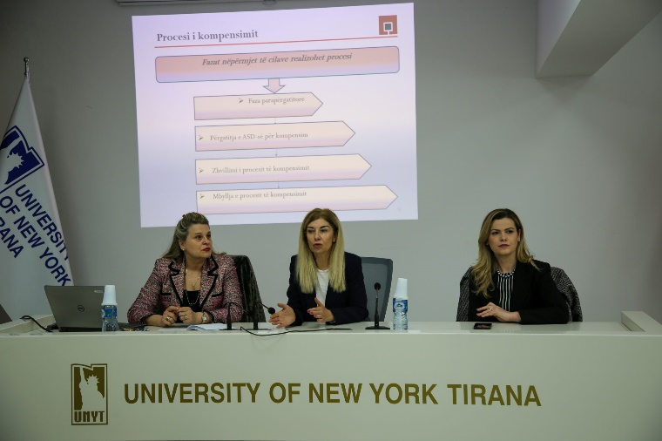
Even during 2024, the Agency continued its cooperation with universities to hold open lectures with students, specifically at the New York University of Tirana and the Faculty of Economics at Luarasi University. The lectures were attended by bachelor’s and master’s students. Our goal was not just to deliver basic knowledge about the deposit insurance scheme, but also to show how it works and impacts the banking market and financial stability in the country.
In addition, in cooperation with the Albanian Association of Banks, we held various training sessions for students who competed in both the National Economics Olympiad and the International Economics Olympiad (IEO). The students were trained and provided with information regarding the deposit insurance scheme in the country, as well as the deposit insurance schemes around the world and their impact on the countries’ financial and banking stability.

5.2.3. Promotion of the scheme by informing depositors in bank branches
Even during 2024, the Agency continued to promote the scheme by distributing promotional materials in bank premises such as leaflets, information labels with the ADIA logo, brochures containing information about the deposit insurance scheme in the country, and thematic videos produced by the Agency for the national deposit insurance scheme.

5.3. Activities at international level
We consider cooperation with international organizations and institutions essential for benefiting from the best experiences in the deposit insurance field. To this purpose, in 2024, within the framework of membership in international deposit insurance organizations such as IADI and EFDI, as well as in view of the protocols signed with counterpart institutions, we had a proactive commitment as follows:

5.3.1. Contribution at international forums

The Agency follows European and global developments regarding deposit insurance systems and financial crisis management, and participates in various activities aimed at the mutual and ongoing exchange of institutional experiences. The Agency's capacities have grown significantly as a result of long-term cooperation with deposit insurance associations, other international financial organizations, and counterparts, allowing it to become not only a beneficiary but also a contributor to international forums.

In this regard, in 2024, the Agency co-hosted and organized with the European Forum of Deposit Insurers (EFDI) a successful and comprehensive two-day event with several working groups from this forum. More specifically, meetings were held with members of the EFDI Stress Testing Working Group (STWG), the Public Relations Committee (PRC), and the Cross-Border Communication Subgroup (CBCS). Participants in these meetings offered the approaches and experiences of the organizations they represent on essential topics for an effective deposit insurance and compensation process, such as stress testing exercises to verify the ability of deposit insurers to respond to critical situations, effective communication with depositors, and cross-border relations among deposit insurance authorities to address problematic situations in financial institutions which activity extends to different jurisdictions.

5.3.2. Cooperation with the Hungarian Deposit Insurance Fund
In May and October 2024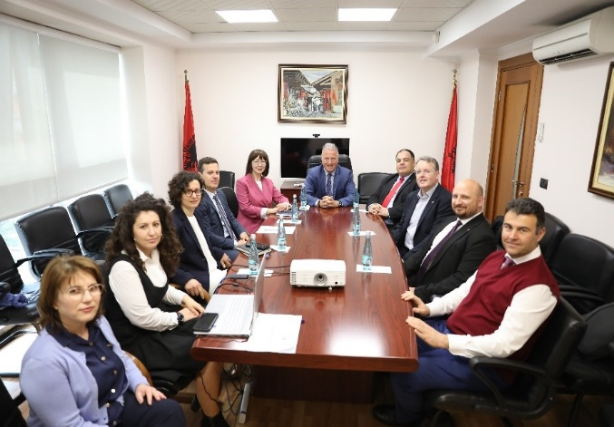, the Deposit Insurance Agency and the Hungarian Deposit Insurance Fund (OBA) conducted mutual study visits under a bilateral cooperation agreement aimed at exchanging information and professional experience in the fields of deposit insurance and resolution funding.
Taking into account Hungary’s status as an EU Member State, and the structural and operational similarities between the ADIA and the OBA, in addition to technical issues of mutual interest, discussions included the current stage and expected progress of proposals for changes to the European Union legal framework for financial crisis management and deposit insurance, as well as the ADIA’s steps towards legal framework compliance with the with EU Directives.
In addition to EU membership topics, experts from both authorities examined, among other things, the possibilities of advancing information technology in deposit compensation procedures, current information security issues related to deposit insurance, particularly cyber security issues, the changing role of deposit insurance institutions in the financial safety net in terms of preventive and alternative measures, and the role of deposit insurers in the liquidation process of scheme member entities.
Also, within the framework of bilateral cooperation, the topics discussed included solutions for efficient compensation processes, cooperation between authorities that are part of the financial safety net, improved practices for establishing supporting infrastructure to ensure operational continuity, and so on.
The institutional relationship between the two institutions is considered quite productive, and for this purpose, both the ADIA and the OBA are committed to continuing the coordination and implementation of cooperation protocols on identified issues of common interest.

5.3.3. Cooperation with the Kosovo Deposit Insurance Fund
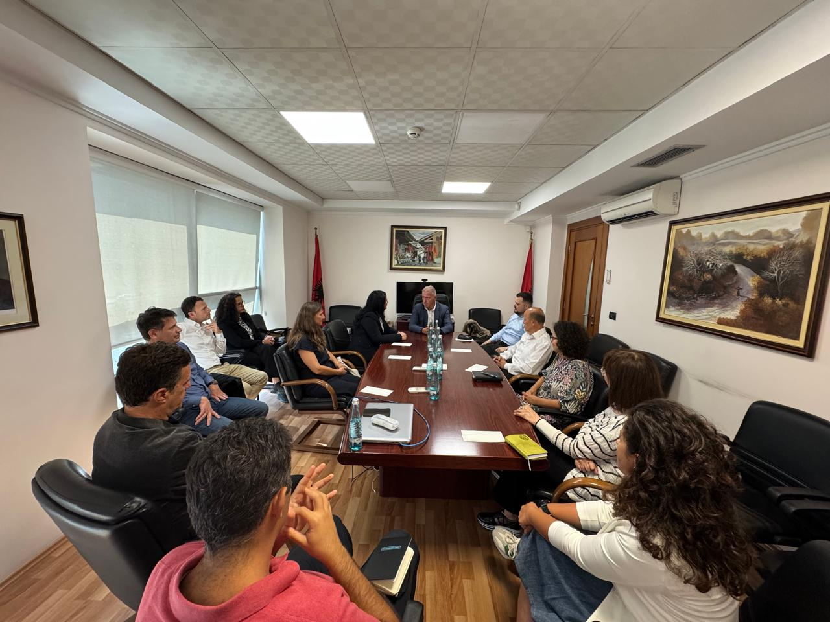
In September 2024, the ADIA welcomed a delegation from the FSDK. Mrs. Shqipe Devaja, the FSDK’s recently appointed Managing Director, led the delegation. On this occasion, Mr. Genci Mamani, General Director of the ADIA, welcomed Mrs. Devaja and wished her success in her new assignment, expressing the willingness to continue cooperating and providing further support to strengthen the deposit insurance system.
During the visit, the two institutions discussed recent developments in both jurisdictions, as well as European developments on the expected reforms in the deposit insurance field. At the end of the visit, based on current cooperation protocols, both institutions committed to continue and deepen cooperation with the aim of advancing the deposit insurance systems according to European and international standards.

Section 6 – Good governance of the organisation

6.1. Governing Council
According to the Law No. 53/2014, dated 22/05/2014, “On Deposit Insurance”, as amended, and the Statute of the Agency, the Governing Council is the highest decision-making body of the Deposit Insurance Agency, responsible for the performance and proper functioning of its activities and operations. The role of the Governing Council focuses on its supervisory responsibilities, acting independently and assessing the performance of the Agency’s management against legal requirements, recommendations from the constitutional institutions (the Assembly of the Republic of Albania) and supervisory institutions (Bank of Albania), to which the Agency reports, as well as the objectives set out in the Agency’s regulatory acts. The Governing Council consists of five members appointed by the Supervisory Authority. Two members are proposed by the Supervisory Authority, two members are proposed by the Minister of Finance of the Republic of Albania, and one member is proposed by the Institute of Authorized Chartered Accountants. The members of the Governing Council are non-executive, with the exception of the member appointed to the position of General Director.
The Governing Council of the Agency consists of the following members:
GOVERNING COUNCIL | FUNCTION | PROPOSING INSTITUTION
Donald Duraj | Chairman | Bank of Albania
Genci Mamani | Member | Bank of Albania
Adelina Xhemali | Member | Minister of Finance
Vasilika Vjero | Member | Minister of Finance
Shkëlzen Margjeka | Member | Institute of Authorized Chartered Auditors (IEKA)
Based on their obligation to act honestly at all times in the best interest of the Agency, the members of the Governing Council exercise their activity in accordance with the powers set out in Law No. 53/2014, dated 22/05/2014, “On Deposit Insurance”, as amended, the Statute of the Deposit Insurance Agency, the Regulation “On rules and procedures of functioning of meetings of the Governing Council of the Deposit Insurance Agency”, and the applicable legislation for collegial bodies.
In 2024, the decision-making process of the Governing Council was guided by the principles of lawfulness, professionalism, independence, and transparency. According to the approved program for 2024, the Governing Council has made 29 decisions with the goal of establishing and maintaining high standards for the good governance of the Agency while also consolidating its capacities to fulfil its legal mandate. The decision-making of the Council was primarily focused on the approval of by-laws aimed at the proper administration of the deposit insurance scheme, and the smooth running of the operational activity of the Agency.

6.2. Organizational structure
The organizational structure of the Deposit Insurance Agency was approved by Decision No. 19, dated 29/08/2013, of the Governing Council, “On the approval of the organizational structure, staff, and number of employees in the Deposit Insurance Agency”, as amended.
Based on the Statute of the Agency approved by Decision No. 24, dated 31/10/2018, of the Governing Council, and in accordance with its organizational structure, the Agency is organized hierarchically, headed by the Governing Council and administered by the General Director.
According to this structure, the Agency is composed of 7 sectors, and has a total of 29 job positions. The following organizational chart represents the organization of the Agency in units.
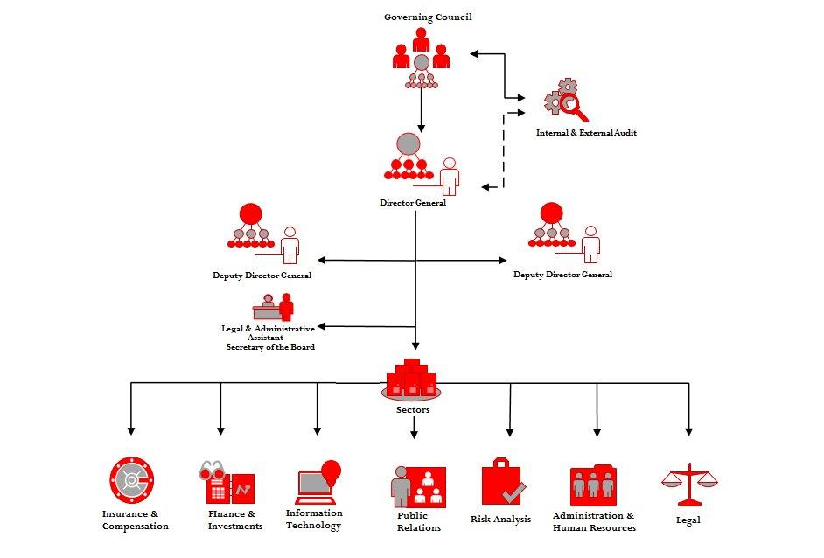
In 2024, the Agency continued to develop and train human resources, focusing on increasing professional capacities and improving workplace performance. The organized trainings aimed not only at developing technical skills, but also at strengthening managerial competencies, communication and cooperation among employees.
In the framework of this approach, employees had the opportunity to participate in a series of training programs conducted both domestically and abroad, organized by international institutions such as EFDI, IADI, or other counterpart institutions.
The Agency aims to achieve the optimal level of professional capacities through effective human resource management, as well as to direct the most efficient use of these resources in accordance with the institution's development policies, in order to fulfil its mission and objectives.

Section 8 – Resolution Fund

8.1. Administration of the Resolution Fund
The Bank of Albania is the Resolution Authority that exercises the resolution rights set out in Law No. 133/2016, dated 22/12/2016, “On Recovery and Resolution of Banks in the Republic of Albania”. The Deposit Insurance Agency has been assigned the powers to administer the Resolution Fund.
The Resolution Fund is administered in accordance with the RF’s Policy on the Administration of Financial Assets, approved by the Resolution Authority. The first contributions to the fund were paid in January 2018. The Bank of Albania calculates each year the annual contribution that the banking sector will pay to achieve the target level of the Resolution Fund. The annual contribution paid by banks in 2024 was ALL 982.1 million, while the contribution paid in seven years amounts to ALL 5.21 billion. As of December 31, 2024, the book value of the net assets available to the Resolution Authority was ALL 5.73 billion. The Fund's financial assets have been invested in accordance with the Annual Investment Strategy for 2024, approved by the Agency's Investment Committee. At the end of 2024, these financial assets with a nominal value of ALL 5.67 billion were all invested in Albanian Government securities, one-week deposits, and current accounts with the Bank of Albania. The Fund's income from the administration of financial assets for 2024 was ALL 219.6 million.
The Agency prioritizes the effective management of the fund’s financial assets. At the end of 2024, 12.13% of the portfolio was invested in highly liquid instruments, such as current accounts and deposits with the Bank of Albania and securities with remaining maturity of up to 90 days.
The following graph represents a summary of the RF’s financial assets by investment tranches, as of December 31, 2024.

Financial assets by investment tranches

RF’s financial assets are mostly in ALL. In accordance with RF's Financial Assets Management Policy, investments in foreign currency constitute 5.24% of financial assets under administration. The following graph represents a summary of RF's financial assets by currency, as of December 31, 2024.

Financial assets by currencies

The Agency maintains separate accounts for the RF's financial assets to administer the Resolution Fund. The Agency compiles the fund's financial assets portfolio, as well as its quarterly financial statements, and reports to the Resolution Authority. The annual financial statements of the Resolution Fund are audited by certified and independent auditing firms.

According to Law No. 53/2014, dated May 22, 2014, “On Deposit Insurance”, as amended, “eligible deposit” is the aggregate value of all deposits of a depositor, including their interest calculated on the day of evaluation or intervention in an entity member of the scheme, except for the exclusions under Article 32 of this law.
The total number of depositors is determined by collecting the aggregated data reported by each bank; therefore a person who has deposits in several banks is registered several times.
According to Law No. 53/2014, dated May 22, 2014, “On Deposit Insurance”, as amended, “insured deposits” are part of the eligible individual deposits covered with insurance by the Agency. .

