# http://www.qarkushkoder.org/foto/stemazyrtare.gif

REPUBLIC OF ALBANIA

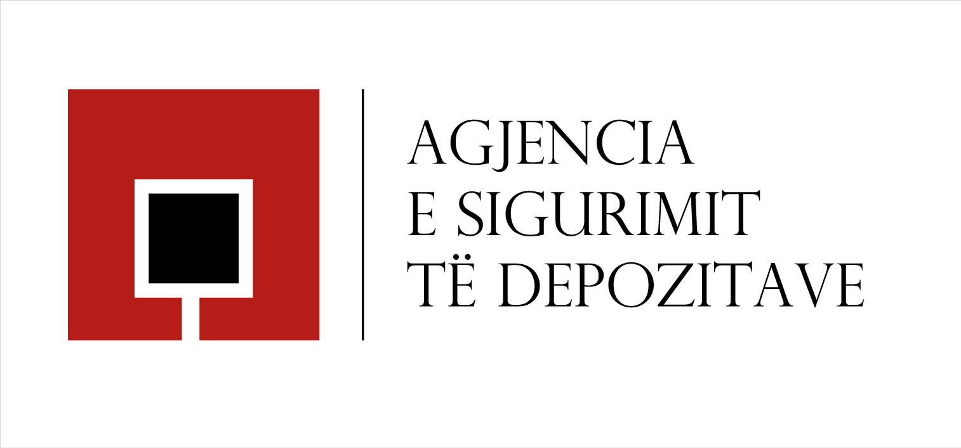

**Annual Report 2015**

Contents

1

**Section 1 - Introduction** 4

**1.1.** **Message of the Chair of the Board of Directors and General Director** 4

**1.2.** **The Agency’s Profile** 6

**Section 2 –Strategic Plan 2015-2017 and main projects** 7

**2.1.** **Strategic directions** 7

**2.2.** **Strengthening professional efficiency** **in case of a payout process** 8

2.2.1. Simulation exercise 8

2.2.2. Crises simulation exercise with the financial safety net members. 9

2.2.3. Improvement of regulatory framework 10

**2.3.** **Increasing public awareness** 10

2.3.1. Cooperation with members of the deposit insurance scheme 11

2.3.2. Promotional initiatives 11

**2.4.** **The efficient administration of the Agency** 12

**2.5.** **Expansion of the deposit insurance scheme** 13

**2.6.** **International collaboration** 14

2.6.1. Experience exchange with regional counterpart agencies 14

2.6.2. Extending Cooperation with Homologous Deposit Insurers 15

**Section 3** – **Banking sector performance and progress of deposits** 17

**3.1.** **Banking system, main indicators** 17

**3.2.** **Deposits in the system** 19

**3.3.** **Individual deposits** 19

**3.4.** **Insured deposits** 23

**3.5.** **Verification process** 26

**Section 4 - Budget and Financial resources available to the Agency** 27

4.1 Performance of the Deposit Insurance Fund 27

4.2. Key financial indicators 28

4.3. Coverage ratio of insured deposits in banks 29

4.4. Financial assets management 32

4.5. Financial resources available to the Agency 34

4.5.1. Deposit insurance funds 34

4.5.2. Loan Agreements 34

4.5.3. The insurance premiums and the special contribution 35

4.5.4. State Budget 35

**Section 5 –Governance of the Agency** 36

**5.1.** **Board of Directors** 36

**5.2.** **Organizational structure** 38

**5.3.** **Internal audit** 42

# **Section 1 - Introduction**

## **Message of the Chair of the Board of Directors and General Director**

During 2015, the Albanian banking system remained healthy and with a positive trend, offering safety and enjoying the trust of Albanian and foreign clients. However, we at the Deposit Insurance Agency, believe that such progress and stability is not a reason for overconfidence.  Despite the market setting and financial condition of the banking sector, as deposit insurers, we are constantly committed in developing our capacities in order to respond to potential scenarios that require the Agency’s intervention, in pursuit of fulfilling our mandate.

In the past year the Agency has made significant progress in successfully accomplishing the key strategies and objectives set for the year, in line with the performance indicators envisaged in the Strategic Plan 2015-2017:

1. *strengthening professional efficiency and readiness for pay-out* – the Agency conducted simulations among its staff and other financial safety net institutions in the country, to test its readiness for a potential payout. This also served to further improve the legal and regulatory framework for compensation;
2. *increasing the level of depositor awareness* – the Agency further intensified its relations with the banking sector as a strategic partner for the promotion of deposit insurance scheme, as well as utilised a number of other mediums to communicate with the public.
3. *efficient administration of the Agency* – the planning of a challenging and realistic budget for 2015 was successfully implemented in conformity with the Strategic Plan, thus enhancing the Agency’s operational efficiency.

As members of the Financial Stability Advisory Group, the Agency is fully engaged in offering expertise through conducting studies, giving opinions and information, which are vital in the decision making of this forum, important for the financial safety in the country.

In addition, during 2015 the Agency intensified its ties with international organisations, aiming at updating the scheme with best practices in deposit insurance. In this context, of major importance was the cooperation with homologous institutions in the region which allowed for the exchange of experiences related to past insurance events.

The Agency proposed a draft law which, among others, envisages the expansion of the deposit insurance scheme with legal persons. The provisions of this draft law follow the recommendations of the Albanian Parliament’s Resolution “For the evaluation of the activity of the Albanian Deposit Insurance Agency for year 2014”, as well as best international standards and practices. These proposed changes expand the base of the scheme’s beneficiaries, contributing towards strengthening financial stability in the country and increasing the trust of Albanian depositors.

As in previous years, in 2016 we will continue our work zealously in order to fulfil the Agency’s objectives. Intensifying simulations that test the institutions’ readiness for pay-out, including credit and savings associations in the scheme and further strengthening the public’s awareness on the deposit insurance scheme, are the three main aspects on which our work will focus. By this we aim to give Albanian depositors clarity, stability and safety, thus contributing in the sustainability of the financial system of the country.

We are aware that it is of significant importance for us to be vigilant and ready at all times to fulfil our legal mandate. For this, we remain attentive to developments in the financial and banking system in the country, in order to be ready to respond to all kinds of challenges.

In this spirit, the Annual Report 2015 summarises the main projects and developments during this year, as well as the performance of deposits in the banking system and the deposit insurance fund in the Agency’s administration.

|  |  |
| --- | --- |
| Donald Duraj | Genci Mamani |
| Chair of the Board of Directors | General Director |
|  |  |

## **The Agency’s Profile**

The Deposit Insurance Agency was established in 2002 and runs its activity in pursuit of law no. 53/2014, date 22.05.2014 “On Deposit Insurance”. The Agency’s mandate is the administration of the deposit insurance scheme, which ensures the deposits of individuals in all banks that operate in the Republic of Albania (16 banks). The law “On Deposit Insurance”, also empowers the Agency to insure deposits in credit and savings associations.

Based on the law “On Deposit Insurance”, the Agency insures up to 2.500.000 lek the deposits of individuals for each bank that is a member of the deposit insurance scheme. In addition, the Agency insures up to 2.000.000 lek the deposits of individuals for each savings-credit associations that is a member of the deposit insurance scheme.

Deposits in foreign currency are insured up to the same amount but are compensated in lek, on the basis of the exchange rate on the day of intervention by the Supervisory Authority (Bank of Albania). According to the law, the Agency shall compensate depositors within 3 months from the day of intervention by the Bank of Albania in an insured subject. The Agency can also use other methods which would fulfil its obligation to compensate deposits, for example transferring funds (which represent insured depositor rights) in Purchase & Assumption. The subjects that are member of the deposit insurance scheme pay quarterly insurance premiums to the Agency for insuring their deposits.

ADIA is administered by a Board of Directors and managed by the General Manager. ADIA is a ‘paybox’ system, in accordance with the standard determined by the International Association of Deposit Insurers (IADI).

**Section 2 –Strategic Plan 2015-2017 and main projects**

## **2.1. Strategic directions**

In early 2015, the Agency prepared a three-year Strategic Plan 2015-2017. This Plan sets out the Agency's strategic direction, its focus and priorities that guide all the activities of the three-year period, which are regarded as key factors in its success.

The drafting of the Strategic Plan is based on a detailed analysis of the strengths and weaknesses of the Agency in terms of the commitment and offering depositor protection, as well as the implementation of deposit insurance policies.

The effective implementation of this plan takes into account the current level of deposit insurance fund and the availability of financial resources, operational capabilities and the commitment of the Agency structures, as well as the cooperation at national and international level, among others, with the Financial Safety Net members in the country and international organizations of deposit insurers.

Based on this Strategic Plan, the priority for the insurance scheme and the Agency mandate as its administrator, is preparing for an effective compensation to depositors within legal limits. During 2015, the work in this direction mainly focused on (i) testing the capacity of Agency in the context of institutional cooperation with the Financial Safety Net members; (ii) operational interaction between the Agency structures; (iii) regulating the relationship between the deposit insurance system members, through the review of the regulatory framework; and (iv) initiatives to increase public awareness, as one of the key factors for maintaining financial stability in the country and protecting the insured depositors.

Furthermore, in order to fulfil the strategic directions during 2015, the Agency has been engaged in efficient administration of the financial instruments.

## **Strengthening professional efficiency** **in case of a payout process**

### Simulation exercise

In May 2015, the Agency for the first time conducted an exercise to test systems and procedures in function of reimbursement of insured depositors. In accordance with Agency's Strategic Plan 2015-2017, the simulation exercise objectives were testing: (i) the functioning of the IT System of ADIA; (ii) the efficiency of previously prepared standard procedures and manuals, (iii) staff readiness to respond promptly and accurately to a payout process, (iv) identification of potential areas for improvement.

*How was the simulation exercise prepared?*

*In the preparatory phase, a selected team of the Agency prepared the simulation scenarios, which were not communicated to the staff until the start of the simulation.*

*The simulation scenario describes the chronology of the events in real time and simulated time, starting from the moment of receiving the official notification from the Supervisory Authority until the closure of the reimbursement of depositors.*

*Standard documents (templates) were prepared and used during the simulation. Also, the respective roles of each employee were determined in advance.*

*For simulation purposes, one of the banks operating in Albania was selected.*

One of the main issues of the simulation exercise was the receipt of a list of depositors through the System and the accuracy and validity of the data of depositors. From the tests it turned out that the IT system of the Agency produced the list with 80% accurate and ready for compensation.

Also, in the Agency's focus was the compliance of the payout process with the respective legal and regulatory framework. This includes the decision-making process by the designated authorities and the dissemination of information, in order to respect the legal deadlines. Exercise tested the existing documents and identified the need for drafting other template documents to increase effectiveness and readiness in case of a payout process.

As a conclusion, issuing the list with single customer view, remains a challenge for a prompt and accurate payout process.

Furthermore, simulation helped management identify key areas requiring attention and improvement, and also highlighted the importance of overall simulation exercises with all outsourcing service providers (Agent Bank, audit firms, etc.), as well as better co-ordination with other financial system safety-net participants to effectively deal with circumstances that may affect the financial stability.

In order to address the issues arising from the exercise of capacity testing, the ADIA reviewed and prepared the Regulatory Payout Framework, including the "Deposit Reimbursement Regulation", as well as started work on the compilation of the detailed plan that goes along with this regulation, and the check list for each unit in the ADIA, in case of a payout.

### Crises simulation exercise with the financial safety net members.

Global financial instability has highlighted the importance of having effective coordination arrangements among responsible authorities as well as a smooth and synchronized operational relationship between the different units within the authorities mandated to manage financial crisis.

Considering the above, a Crisis Simulation Exercise (CSE) was conducted on June 2015, as part of a Technical Assistance project funded and delivered by the Vienna Financial Sector Advisory Centre (FinSAC) for the Bank of Albania (BoA). The overall goal of the Exercise was to examine how the authorities respond to distress in the financial system and to explore the adequacy of existing laws, regulations, policies and procedures to confront those challenges.

Simulation Exercises are powerful tools which serve to test the functioning of existing mechanisms and procedures in the event of financial crisis. The issues identified range from shortcomings in the legal and regulatory framework, gaps in the operational procedures, lack of (or poor) implementation of information sharing and coordination mechanisms among relevant agencies, ineffective communications with key stakeholders to misguided communication with the public, etc.

Participants in the Simulation Exercise were all the composing authorities of the Albanian financial safety net, such as, Bank of Albania, Ministry of Finance, the Albanian Financial Supervisory Agency and the Albanian Deposit Insurance Agency. All these authorities were represented by very high ranking officials.

Upon conclusion of the Simulation Exercise, the Financial Sector Advisory Centre (FinSAC) experts delivered various recommendations aiming to enhance the inter-institutional collaboration in the occurrence of a financial crisis. One of the recommendations directly linked with the activity of the Albanian Deposit Insurance Agency and its contribution in solving timely and efficiently problematic situation for the financial stability, was exploring possibilities on how to secure the necessary liquidity for the deposit insurance fund in due time. For this purpose, it was recommended to evaluate the possibility for the Banka of Albania to enter into a direct repo transactions with the Albanian Deposit Insurance Agency. Following these recommendations the Agency is seriously engaged to address all related issues through institutional collaboration and joint legal initiatives with the respective authorities, such as Banka of Albania and Ministry of Finance.

### Improvement of regulatory framework

Following the approval of the Law no. 53/2014, of 22.05.2014 “On deposit insurance”, the Agency focused on the revision of the regulatory framework regarding deposit compensation process aiming to maintain consistency with the provisions of the deposit insurance law, Directive 2014/49/EU of the European Parliament and Council "On deposit guarantee schemes “of 14.04.2014, as well as the Core Principles for Effective Deposit Insurance Systems adopted by International Association of Deposit Insurance (IADI), in 2014. In this regard, the Agency has drafted a new regulation “On compensation of insured deposits”, which comprehensively improves the deposit compensation process. The main improvements introduced in the draft regulation are: the detailed regulation of the preliminary phase for the implementation of the compensation process; requirements and procedures for selection of the agent bank and other service providers; definition of rules for the use of Agency’s IT System on Data Collection and Reporting during a compensation process, as well as interaction with other involved subjects in this process.

This new regulatory framework represent a major step forward in establishing the infrastructure for an efficient and prompt compensation of depositors in an insurance event, which is the main objective of deposit insurance scheme in order to maintain the financial stability.

## **Increasing public awareness**

The law “On deposit insurance” charges the Agency, as the only financial institution for deposit insurance in the country, in fulfilment of its mandate and mission, to promote in continuance the deposit insurance scheme.

Appreciating that informing and educating the public on the deposit insurance system is essential, not only to manage as good as possible an insurance event, but it contributes to strengthening and safeguarding financial stability in the country, during 2015, projects continued to promote deposit insurance scheme and the development of the Agency image.

The combination of communication tools and methods aimed the biggest breakthrough at all levels of public, taking into consideration factors such as depositors and non-depositors public, levels of education, interest-group categories, age groups, demographic characteristics of the target audiences, etc.

### Cooperation with members of the deposit insurance scheme

Communication with member entities of the deposit insurance scheme is a priority for the Agency, taking into consideration the strategic role that they have in promoting the scheme. In cooperation with the Bank of Albania and the Albanian Association of Banks, during 2015, trainings were organized with the employees of banks in Tirana, Fier, Shkodra, Vlora and Korca. The main focus of the trainings was to increase further the level of education and awareness with elements of the scheme; the necessity of keeping the data of depositors in accordance with the legal defined criteria; the importance of the cooperation and contribution of all human resources to promote deposit insurance scheme; elements that contribute to the successful realization of an insurance event. Banks participating in training, qualitative discussions and questions of the participants, showed the necessity of cooperation in continuance between the Agency and the banks in different cities.

### Promotional initiatives

Educational Promotional Video

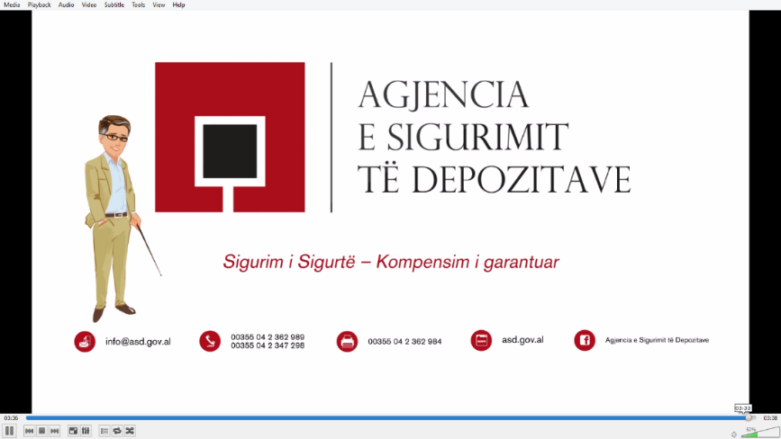For the first time the Agency conducted a production of an educational animated video. Taking into consideration that the information transmitted via this medium, it is easily perceptible by all ages and interest groups, the Agency intention was to broadcast the video (illustrated in the most appropriate and creative way with inputs, graphics and animations) to convey basic information by describing the essential elements of the functioning of the deposit insurance scheme in Albania. The video is published on the official website of the Agency as well as on social media profiles, aiming the transmission of the information in line with trends in the field of public communication.

Agency Annual Report

The Agency is a public institution, which in accordance with the Law “On Deposit Insurance” reports to the Parliament, to The Council Of Ministers and to the Supervisory Authority for its annual activity. Based on the principles of transparency and accountability the Agency in 2015 prepared and reported the Annual Report for 2014. Judging that this material is a comprehensive and detailed source of information of the activities of the Agency, the Annual Report, after reporting to the Parliament, it is distributed to groups of interests and also published on the official website of the Agency.

Official Internet Website of the Agency, as an important mean of exposure of the role and the function of the Agency, during 2015 was developed as in the visual aspect, also in the content. Configuration sections and new web applications of the site allowed greater interaction with the interested parties, compared to previous years.

Agency Profile in Social Networks, innovative in communications with the public, is updated continuously with materials and information about the activity of the Agency. Besides the transparency with the depositors and the public, this profile enables the creation of channels of communication with two-way flow of information.

## **2.4. The efficient administration of the Agency**

The fulfilment of the Agency’s legal mission and objectives in safeguarding financial stability and the citizens trust in it, requires an efficient financial administration of the Agency’s insurance funds. The Agency is in a continuous process of improving its operational efficiency, which is why the Agency’s Strategic Plan 2015-2017 envisages the fulfilment of the approved budget with a variance of not more than 10% as a key success factor for the Agency. This requires a comprehensive engagement from all sectors of the Agency to draft a challenging and realistic budget, as well as monitor its timely fulfilment throughout the year.

The fulfilment of the legal objectives of the scheme and Strategic Plan have financial implications. In drafting the budget, the Agency is focused in making available the necessary funds for achieving the scheme’s objectives, as well as administer with efficiency its financial means in order to further expand deposit insurance funds. Periodic monitoring of its fulfilment enables the managing bodies to evaluate the institutions’ work throughout the year in line with the objectives set and undertake any steps considered necessary to address issues which require further attention.

In drafting the budget for year 2015, the Agency aimed at keeping current expenses not more than 25% of the planed income from the administration of its financial means. These expenses were envisaged as 5.7% of the total of the Agency’s planed income. The Agency’s structures evaluated that keeping these expenses in these values enables the fulfilment of its objectives as well as guarantees the expansion of the deposit insurance fund through net income throughout the year. As a result, realistic planning and realization of income, particularly from the administration of financial means, is an important condition for the expansion of the deposit insurance funds and expenses related to the Agency’s activity and objectives for the year.

For the year ending on 31st December 2015, total income was realised 102.8% from the plan for the year. Income from insurance premiums and the administration of financial means were realised 101.4% and 104.9% respectively. Current expenses were realised 90.8% compared to the plan, with operating expenses realised 89.9% and personnel expenses 92%. The plan for capital expenses for year 2015 was realised 55.2% as some of the projects planned for 2015 were re-evaluated and postponed for the next year. Based on the data above, current expenses for the year amount to 22% of the income from the administration of financial means and 5% of the total income.

## **Expansion of the deposit insurance scheme**

During 2015, significant developments took place following the legal initiative undertaken by the Agency aiming to harmonize the deposit insurance scheme with the Directive of the European Parliament and Council 2014/49/EU “On deposit guarantee schemes”. The main goal of this legal initiative is the inclusion in the scheme of deposits of the traders and companies, in accordance with the recommendations of Albanian Parliament's resolution dated 06.11.2015 "On the assessment of the activity of the Deposit Insurance Agency for 2014", as well as the recommendations of the World Bank mission in the framework of the action plan for the implementation of development policy for modernizing the financial sector. Expansion of the deposit insurance scheme by including deposits of traders and companies is proposed to take effect on January 1st, 2017 and aims to contribute in strengthening of the financial stability in Albania, through increasing the base of depositors protected by the scheme, and increasing their confidence in the deposit insurance scheme.

An important part of the legal amendments, drafted by the Agency, are as well the provisions aimed at guaranteeing a prompt access of the Agency in liquidity through a review of its right to sell and repurchase securities to the Bank of Albania, as well as the coordination of the restructuring process of the savings and loans associations and their unions, with their inclusion within the scheme through a review of the transitional provisions of the applicable law on deposit insurance.

During 2015, the financial sector of SCA has passed though deep structural and regulatory changes, which were initiated by the World Bank, aiming to consolidate and strengthened this sector. The Agency worked closely with the Supervisory Authority, as well as with the World Bank and savings and loans associations to initiate the legal initiative on the proposal of these amendments.

At the end of 2015, the Agency completed the consultation phase for these legislative changes with public institutions, and actually the draft-law is under review for approval by the respective legislative bodies. Legal amendments drafted by the Agency, are a step forward for continued development of the deposit insurance scheme of our country in accordance with International Standards for Effective Deposit Insurance Systems, as well as Directive 2014/49/EU of the European Parliament and Council "On deposit guarantee schemes".

## **International collaboration**

The Agency adheres in international deposit insurance organizations and thus the activities related to international collaboration area have continued throughout 2015.

Since its full-rights membership in 2003, the agency holds continuous relations with IADI (International Association of Deposit Insurers), mainly through participation in its annual general assemblies, which serve as forums to exchange views on the deposit insurance field. In recent years, the role of IADI in the international financial environment has increased significantly due to the inclusion of its Core Principles for Effective Deposits Insurance schemes in IMF’s and World Bank’s financial systems assessment program (FSAP). The Agency is included in special IADI committees and structures at a regional scale and beyond, such as the European Regional Committee and the Finance and Planning Committee. Participation in such high level committees served to the Agency as a platform in order to give its contribution in important decision making processes for the governance of the association.

The Albanian Deposit Insurance Agency is also a full-right member of the European Forum of Deposit Insurers (EFDI). EFDI is the main partner of the European Commission concerning matters of deposit insurance. In the framework of recent developments relating to deposit insurance with the approval of the Directive 2014/59/EU “Bank Recovery and Resolution Directive” and Directive 2014/49/EU “On deposit guarantee schemes”, collaboration with EFDI is considered of particular importance in light of Albania aspirations for joining the European Union.

* + 1. Experience exchange with regional counterpart agencies

In line with similar regulatory and operational initiatives for the consolidation of the Agency’s capacities, the exchange of experiences with regional counterpart deposit insurance agencies was judged as important during 2015. For this purpose, the Agency conducted meetings with homologous institutions which have had insurance events in their respective jurisdictions, and which, from the perspective of their organisational structure and regulatory functions, are similar to ADIA.

Accordingly, meetings with the Deposit Insurance Agency of Bosnia - Hercegovina, State Agency for Deposit Insurance and Bank Resolution of Croatia and Deposit Insurance Fund of Kosovo were held.

The collaboration with colleagues from Bosnia - Hercegovina and Croatia focused on the pay-out events in which these two authorities had been engaged in the past. The meetings aimed at highlighting problematic issues that were encountered during the pay-out process, from the notification from the Supervisory Authority, informing depositors and communication with them, until the final pay-out of depositors insured by the scheme. Furthermore, in the meetings held with colleagues from Croatia, discussions also focused on other topics of mutual interest, such as the management of deposit insurance funds and methods for the its efficient optimisation, compensation procedures and measures taken for the accurate and timely communication with depositors in an insurance event.

In addition, considering the importance of preparation and cooperation in an insurance event, ADIA and the Deposit Insurance Fund of Kosovo evaluated the possibility of coordinating its actions and in this context organising mutual simulation exercises.

* + 1. Extending Cooperation with Homologous Deposit Insurers

In the framework of its policies for enhancing cooperation with national and international institutions, the Agency has a vital interest in consolidating its ties through different communication protocols, with the aim of exchanging experiences, strengthening capacities and improving the deposit insurance scheme in line with best international standards. This is furthered by the recommendations of the FSAP mission of the World Bank and IMF, which evaluate cooperation agreements with homologous deposit insurance schemes as a priority for the Agency.

Accordingly, in December 2015, ADIA, the Deposit Insurance Fund of Kosovo and the Swiss Deposit Insurance Fund (esisuisse) signed a Tripartite Cooperation Agreement.

The Agreement was reached taking into consideration that depositors which operate in the jurisdictions of all three authorities may conduct reciprocal financial transactions among the banking systems involved. In this context, the Agreement envisages the exchange of information among these authorities, focusing on actual developments in their respective deposit insurance schemes, legislative and regulatory changes, data on the maximum coverage level, insurance premiums, public awareness and education policies, information on the regulation of the banking and non-banking sectors, etc. This Agreement is the first Tripartite Agreement signed in the framework of the International Association of Deposit Insurers (IADI).

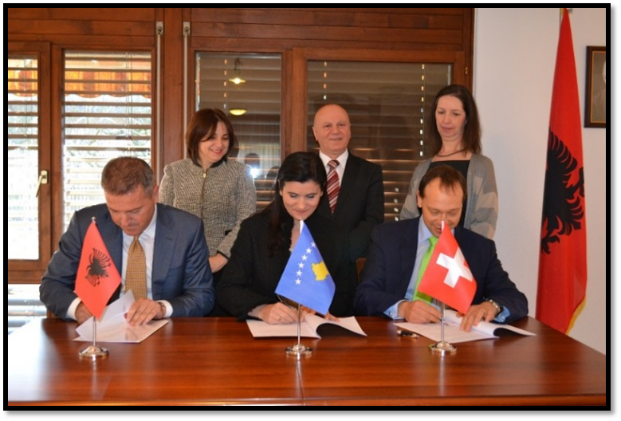

# **Section 3** – **Banking sector performance and progress of deposits**

## **3.1. Banking system, main indicators**

Banking sector in Albania is characterized by a stable structure and development. Assets are funded by almost only retail deposits and the capital support is strong. Assets and capital levels exhibit a growing trend. In 2015 the total number of deposits in the banking system increased by 2.2% in comparison with the preceding year.

Capital adequacy levels are at 15.7% compared to the minimum required of 12%. The liquidity indicator remained high at a level of 41.4%.

Non-performing loans ratio has declined to 18.2% by end 2015, in comparison with 22.8% by end 2014.

*Graph 1. Balance and capital adequacy structure*

Net profit of the whole sector reaches 15.7 billion ALL by end 2015, in comparison to 11.2 billion ALL by end 2014.

*Graph 2. Net profit (million ALL)*

Net profit has always been positive, thus contributing to capital growth. Despite its volatility in the last two years the trend is positive resulting in a ROA of 1.2% and ROE 13.1% in 2015.

*Graph 3. ROA and ROE indicators (%)*

* 1. **Deposits in the system**

During 2015 the total system deposits as well as the individual deposits experienced growing and descending fluctuations with relatively low monthly changing norms. Total of deposits in the Albanian banking system reached 1,061 billion ALL by the end of the year 2015 compared to the 1,038.6 billion ALL in the previous year, indicating an increase of 22.6 billion ALL or 2.2%. The average annual changing rate in deposits for the last seven years was 7.6 %.

*Graph 4.Dynamics of the deposits of the banking system 2002-2015*

* 1. **Individual deposits**

The individual deposits that benefit from the deposit insurance scheme reached 889 billion ALL at the end of 2015 compared to 869.5 billion ALL in the previous year, indicating an increase of 20 billion ALL or 2.3%. These deposits represent 83.8 % of the total deposits. The number of individual depositors who benefit from the scheme at the end of the year 2015 is 2,117,389 and in comparison to the previous year has experienced a growth 3.2 % or 65, 499 depositors.

*Graph 5. Dynamics of the deposits structured according to the benefit from the the deposit insurance scheme*

*( in % of total deposits)*

*Graph 6. Progress of total of deposits and individuals Decr'14-Dec'15*

The individual deposits denominated in ALL held by banks reached 453,3 billion ALL at the end of the year 2015 compared to 451 billion ALL by the end of 2014, with an increase of 0.5 %. These deposits which represent 51 % of the individual deposits are due to 2,121,930 deposits with an average deposit value of 214 thousand ALL compared to 2,078,043 deposits with an average value of 217 thousand ALL a year earlier.

Deposits in currency represent 49% of the individual deposits and the major part of them belongs to the deposits in euro.

*Graphic 7.* *Distribution of individual deposits number according to currencies in % - December 2015*

*Graphic 8. Structure of individual deposits amount according to currencies in % - December 2015*

*Graphic 9. Dynamics of system deposits according to currencies*

* 1. **Insured deposits**

Insured deposits in the banking system are 591 billion ALL and represent 66% of the individual deposits or 56% or the total system deposits, compared to 570,6 billion ALL that they were worth a year ago, indicating this way a growth of 20.5 billion ALL or 3.6 %. In December 2015 the major part of the insured deposits belongs to the deposits in ALL with 58% followed by the deposits in euro and dollar with respectively 37% and 4%.

*Graphic 10. Structure of system insured deposits amount according to currencies in % - December 2015*

Fully covered deposits (equal or less than 2.5mln ALL) represent 42 % of the individual deposits and their total in the end 2015 is 368.17 billion ALL. These deposits belong to 2,028,208 insured depositors, who represent 96% of individual depositors. Compared to the previous year these deposits experienced a growth of 5.5% and the number of depositors who own these deposits grew with 3.3%.

Partially insured deposits (in excess of 2.5mln ALL) went down from 517.36 billion ALL by the end of 2014 to 516.62 billion ALL at the end of 2015 suffering a decrease of 743 mln ALL.

These deposits represent 58% of the individual deposits who profit from the scheme and belong to 89,181 depositors, who represent 4% of the individual depositors

*Graph 11. Dynamics of the individual deposits classified by coverage level*

In the period ranging 2009-2015, the percentage of individual deposits worth up to 2.5mln ALL varies from 40% to 49% of the individual deposits total. In December 2015 fully covered deposits represent 42% of the individual deposits or 62 percent of the insured deposits[1].

*Graf 12. Dynamics of the individual deposits classified by coverage level 2009-2015*

At the end of 2015, the percentage of depositors who are fully covered reached 96% of the individual depositors total that benefit from the deposit insurance scheme. For the period 2009-2015 the percentage of individual depositors with deposits up to 2.5mln ALL varies between 95-96%.

*Graph 13.Dynamics of individual depositors’ number compared to coverage level 2009-2015*

## **Verification process**

During 2015 the Agency has carried out verification inspections in all the banks of Albanian banking system. Likewise, the preceding year, even during 2016 the focus of the inspection teams has been improving the quality of depositor data, single customer view, etc., with the aim to be prepared for a swift and accurate compensation process.

Following the verification process in all the 16 banks of the system it resulted that serious and engaging efforts are being made to update and improve the quality of depositor data, although this remains a challenge.

Along with the abovementioned, a very crucial issue, such as, depositors’ information and awareness on the benefits and limitations of the deposit insurance scheme as well as their knowledge of the compensation procedures, was paid particular attention during the verification process.

# **Section 4 - Budget and Financial resources available to the Agency**

## 4.1 Performance of the Deposit Insurance Fund

The accounting value of the deposit insurance fund in banks on 31 December 2015 which consist on the initial fund of 400 million ALL and accumulated profits over the years reached the value of 27.67 billion ALL. In comparison to the previous year, this fund has increased by 3.62 billion ALL or 15.1%. The chart below shows the trend of the deposit insurance fund for the period 2009 - 2015. During this period, the insurance fund has increased 249.8% from 7.91 billion ALL at the end of 2009 to 27.67 billion ALL at the end of 2015.

*Chart 14. Deposit insurance fund (in thousands ALL)*

In accordance with the Law "On Deposit Insurance", in January 2015, the Agency received from the State Budget 76 million ALL in value as an initial fund for deposit insurance in SCA. This fund, contribution of the State Budget, provides an initial financial basis of the deposit insurance fund in SCA.

## 4.2. Key financial indicators

The Deposit Insurance funds in banks increases or reduces from the net proceeds from the activity of the Agency over the years. The main income that contribute to increased deposit insurance fund in the banks are incomes from insurance activities, the annual premium income from insurance and funds management. The chart below is a summary of the main income for the years 2009-2015.

The incomes from insurance premiums for 2015 were 2.90 billion ALL or 24.2% higher than in 2014. The incomes from insurance premiums over the period 2009-2015 have been increasing, which is directly related to the growth of insured deposits in the banking system in recent years.

*Chart 15. Insurance premiums in Banks (in thousands ALL)*

Until the end of 2014, the annual insurance premium was accounted by banks as 0.5% of the arithmetic average of the level of insured deposits at the end of each working day of a three month period for the last year and would be paid by these entities in four equal instalments. The instalments payment made by entities were done no later than the 15th of April, July, October, and January. In accordance with the Law "On deposit insurance", starting from 2015 the deposit insurance premium is calculated by banks quarterly and not annually. Banks quarterly insurance premium is calculated as 0.125% of the arithmetic average of the amount of insured deposits, which are registered in the bank on the last day of each month of the previous quarter. The quarterly insurance premium for banking institutions has to be paid no later than the 15th of the first month of the quarter which it is paid for.

The incomes from financial assets management of the deposit insurance fund in banks for 2015 were 874 million ALL or 8.73% higher than in 2014. Such incomes over the period 2009-2013 has been growing, which relates directly to the expansion of funds under administration and interest rates of securities. The incomes from management of funds for 2014-2015 are influenced by the dynamics of the interest rates of Albanian government securities who have been decreasing since 2013. In 2015, the performance of incomes from funds management was positively affected by the increase of allowed maturity for these investments. This change was implemented in the second half of 2014 from 12 months to 24.

*Chart16. Incomes from the administration of financial assets from Deposit Insurance Funds (in thousands ALL)*

## 4.3. Coverage ratio of insured deposits in banks

At the end of 2015, the insured deposits in banking system were 591.1 billion ALL or 3.6% higher than a year ago. At the end of 2014, the insured deposits in banking system were 570.5 billion ALL or 2.4% higher than a year ago.

The chart below shows a summary of insured deposits performance in banking system for the years 2009-2015.

*Chart 17. Insured deposits in banks (in thousands ALL)*

The steady growth of the deposit insurance fund in banks and the performance of insured deposits in banking system during the period 2009 - 2015 have led to a continuous increase of the coverage ratio over the years. At the end of 2015, the coverage ratio, calculated as a percentage of the deposit insurance fund in banks compared with insured deposits, was 4.68%. The chart below is a summary of the coverage ratio during the years 2009-2015.

*Chart 18. Coverage ratio of insured deposits in banks*

## 4.4. Financial assets management

As per December 31, 2015, the Agency’s financial assets evaluated under the net - booked value of ALL 27.64 billion, are invested mostly in Albanian Government securities. The Agency has invested certain amount of its assets in USA securities. Aiming to effectively manage its financial assets and to guarantee liquid assets at any time, the Agency has placed some of its funds as a deposit in the Bank of Albania. The chart below is a summary of Agency’s financial assets according the type of instruments on 31 December 2015.

*Chart 19. Financing according to financial instruments (securities)*

Agency’s financial assets are mostly in Albanian currency (ALL) . The agency also holds a portion of its financial assets in foreign currency. The below graph shows a summary of currency – based financial assets investment of the Agency on December 31, 2015.

*Chart 20. Financing according the currencies*

Based on above information on the financial assets of the Agency, the graph below presents financial assets allocation by duration to maturity until 31 December 2015. In order to effectively manage and secure funds at any time in terms of financial needs for liquid assets, financial tools have a scalable distribution by term to maturity. Starting from the second half of 2014, upon approval of Law no. 53/14 "On deposit insurance", the Agency has moved about 15% of its portfolio in instruments with residual maturity of 12-24 months. The previous law "On deposit insurance" allowed investments in instruments with residual maturity of no more than 12 months.

*Chart 21. Securities according to duration to maturity*

## 4.5. Financial resources available to the Agency

### 4.5.1. Deposit insurance funds

The financial assets of deposit insurance fund, which have been expanded over the years, are used to compensate depositors in case of insurance event. At the end of 2015, the coverage ratio, calculated as a percentage of the deposit insurance fund in banks compared with insured deposits, was 4.68%, which is an important indicator about the efficiency of the scheme to respond to legal obligations that the Agency has to the depositors. Agency's financial assets are managed in accordance with the principles of liquidity, insurance and return rates. Thereupon, the Agency maintains a scalable distribution maturity of investments portfolio aiming in any case 25% -35% of its financial assets to be invested in instruments with residual maturity of less than three months. Also, in order to ensure liquidity in case of insurance event, the Agency has entered into agreements with the Ministry of Finance and the Bank of Albania. Under this agreement, the Agency in order to effectively respond to an insurance event, may enter into a REPO agreement with the Ministry of Finance for the securities issued by the Government of the Republic of Albania (can sell its securities, issued by the Government of the Republic of Albania, to the Ministry of Finance with redemption obligation).

The fulfilment of the obligation to compensate depositors in time and the specified amount according the law is necessary to maintain financial stability and strengthen the confidence of citizens in the case of insurance event.

### 4.5.2. Loan Agreements

For this reason, the Deposit Insurance Law has provided to the Agency the ability to address to various financial resources in order to guarantee the fulfilment of its obligations at any time. One of the most important instruments available to the Agency is the right to take loans (borrow). At the end of 2014, the Agency signed a loan agreement with the European Bank for Reconstruction and Development (EBRD) for a credit line up to EUR 100 million. The loan agreement is accompanied by a guarantee of the Albanian Government. In case of insurance event, the Agency can access available funds from the lines of credit in a short time, thus increasing the efficiency of the scheme to respond in time to liabilities towards depositors. During 2015, in order to keep available all instruments for a more efficient scheme, the Agency supported by the government, kept the available amount from credit line in the maximum amount of 100 million EUR.

### 4.5.3. The insurance premiums and the special contribution

The Agency upon the Bank of Albania approval, if deemed necessary to cope with its obligations, may require from the member entities to pay a special contribution. With the proposal of the Agency, Bank of Albania defines the member entities, which for reasons of maintaining their solvency, can be exempted from paying this special contribution. The special contribution of the member parties is collected by the Agency only once during the calendar year. The special contribution is defined in the same amount for all member entities and in any case not more than 1% of the total insured deposits that are registered on the entity on the last day of the preceding month from the date of notification by the Agency.

Moreover, in case of insurance event, aiming to guaranty sufficient funds, the Agency may require to the member entities to pay the premiums ahead of schedule, in an amount not greater than four times the value of the last premium and can also increase the insurance premium in accordance with the legislation in force.

### 4.5.4. State Budget

The above instruments enhance the ability of the Agency to ensure financial means to respond to the obligations towards depositors without having to address to the state budget. Nevertheless, if the funds provided by these instruments are not sufficient, then the Agency can borrow from the state budget, in accordance with the legislation in force. In accordance with above, the Agency has signed an agreement with the Ministry of Finance and Bank of Albania. This legislation allows to the Agency a number of instruments to ensure the timely fulfilment of its obligations to depositors by increasing confidence in the financial system and maintain its stability. Moreover, the legislation in force provides that the Agency can address the state budget for additional financing, only after using the financial resources of the member entities of the scheme thereby protecting the interests of taxpayers. Also providing additional funds in a loan form by the Government guarantees the fulfilment of the obligations to depositors in case of insurance event but also the repayment of public funds received in the coming years.

# **Section 5 –Governance of the Agency**

## **Board of Directors**

The Albanian Deposit Insurance Agency Board of Directors is the highest decision-making body responsible for the governance and operational aspects of the organization.

The Board’s activity during 2015 was carried out in accordance with the provisions determined by the Law “On deposit insurance”, Statute of Albanian Deposit Insurance Agency, Regulation “On the rules and procedures for the meetings of the Albanian Deposit Insurance Agency Board of Directors” and the legislation in force for the Collegial Bodies.

Members of the Agency Board of Directors are non-executives, with the exception of the member who is appointed in the position of Director General. During 2015 the composition of the Board of Directors underwent a couple of changes. Following the resignation of Mr. Toni Gogu (member of the Board and Director General), Mr. Donald Duraj was appointed by the Supervisory Authority as the new member of the Board. Consequently he was elected by the Board as its Chairman. Mr. Genci Mamani, who was serving as Board Chairman, was appointed by the Supervisory Authority as the Director General of the Agency. On this occasion the Agency was visited by the Governor of Bank of Albania, Mr. Gent Sejko. This was the first visit of a Banka of Albania Governor in the premises of the Albanian Deposit Insurance Agency.

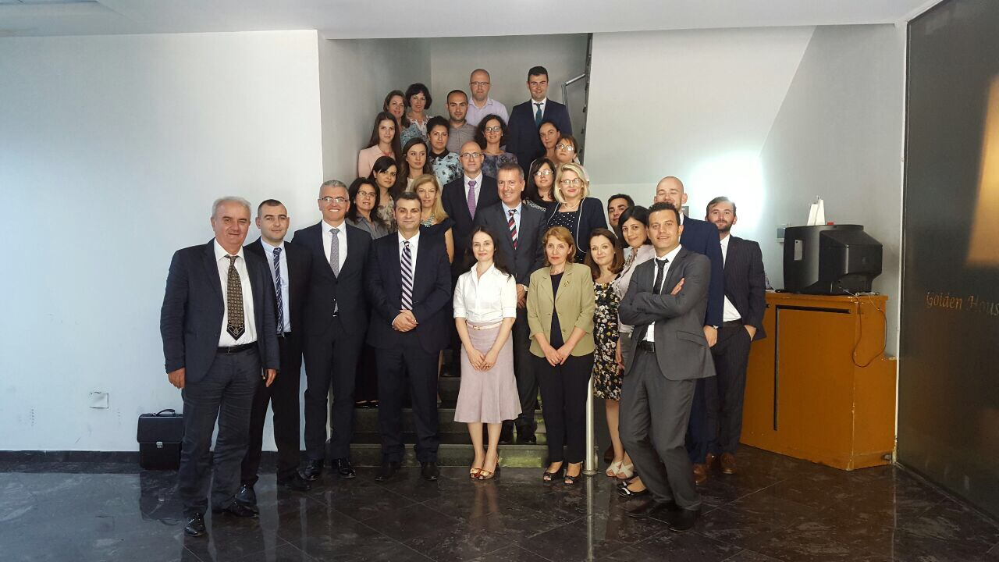

Members of the Board of Directors of the Agency are named for a term of 5 (five) years and may be re-elected based on the performance indicators of their activity.

The board of Directors is composed of 5 (five) members appointed by the Supervisory Authority and proposed as follows:

|  |  |  |
| --- | --- | --- |
| **BOARD OF DIRECTORS** | **ROLE** | **PROPOSING INSTITUTION** |
| Donald Duraj[2] | Chairman | Bank of Albania |
| Genci Mamani[3] | Member | Bank of Albania |
| Erjon Luçi | Member | Ministry of Finance |
| Majlinda Dhuka[4] | Member | Ministry of Finance |
| Doranin Agalliu | Member | Authorized Countable Experts Institute (ACEI) |

In 2015 the Board of Directors carried out 16 meetings, taking the respective decisions (38 decisions) for establishing and maintaining high standards of organizational governance as well as consolidating its capacities in order to accomplish the legal mandate.

With the aim to monitor the progress of strategic directions and addressing all issues related to improving the functions and operational activities of the Agency, the Board of Directors has been informed and subsequently approved, on trimester basis, the budget analysis reports and financial statements. Approval

Some of the most important decisions approved by the Board during its activity in 2015 are related to (i) Approving the Strategic Plan 2015-2017; (ii) Approving the waiver for keeping available the full amount from the Credit Line Agreement between the Albanian Deposit Insurance Agency and the European Bank for Reconstruction and Development (EBRD); (iii) Approving the proposal for the Albanian Parliament related to the necessary legal amendments to include legal entities in the deposit insurance scheme; (iv) Approving the Regulation “On the insurance of eligible deposit”; (v) Approving the Regulation “On the administration of risk in the Albanian Deposit Insurance Agency”; (vi) Approving the audit reports and recommendations of the internal audit; (vii) Approving agreements and MOU’s between the Agency and counterpart institutions, etc.

## **Organizational structure**

The Agency considers human resources as one of the most crucial factors to achieve its goals.

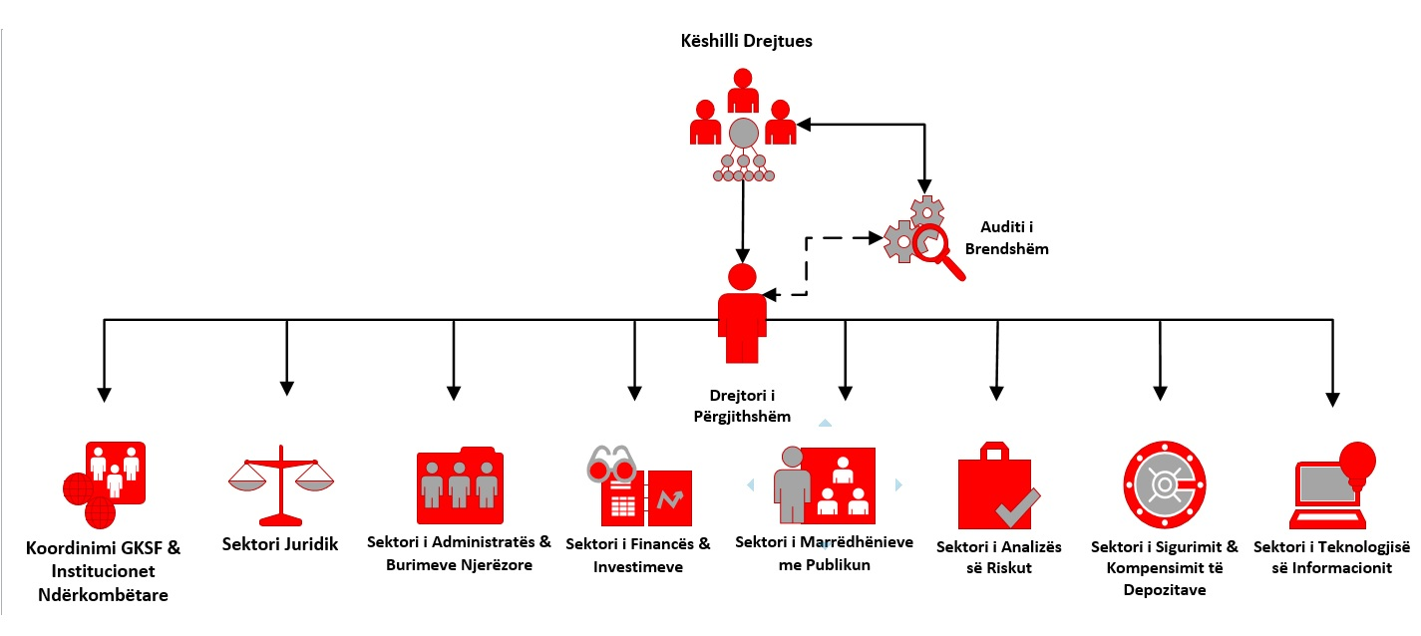

The Agency has a specific structure in the human resource development, according to its objectives. Currently, the Agency works according to the organizational structure approved by the Board of Directors decision, no 19, dated 29 August 2013 "Approving the organizational structure, organism and the number of the employees in the Deposits Insurance Agency”. According to this organizational structure, the Agency is composed of 8 sectors and has 28 staff members. During the last two years, the Agency has fulfilled almost 93% of the vacancies making possible to continue its normal work.

Also, the Agency is focused on the activity management that are related to the identification of the staff needs, staff recruitment, professional skill improvements through training according to the necessities of the professional needs of the job position, administrating correctly the staff files, and also performing the yearly performance evaluation of each employee, in time and in accordance with the specific administrative rules.

According to the data of the employees, it results that the majority of the staff members of the Agency are in the age group of 31-50 years old, although it has an equal distribution of the staff members under the age of 31 years old and over 50 years old.

*Graphic 22. Distribution of the employers according to the age group*

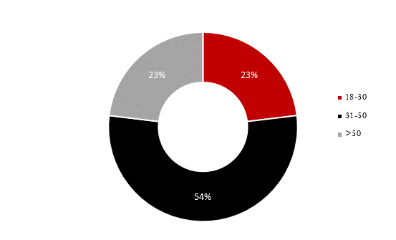

*Graphic 23. Distribution of the employers graduated abroad and in Albania*

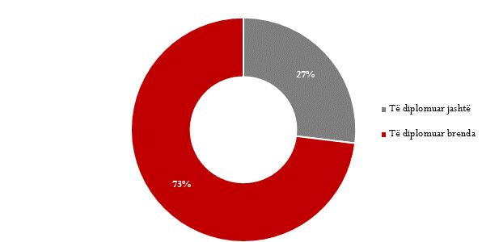

*Graphic 24. Distribution of the employers according the professional education*

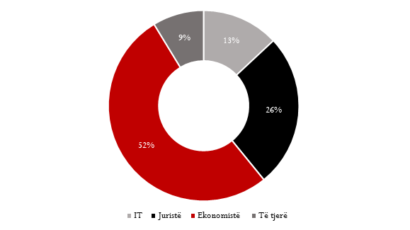

In the job position determined by the organizational structure of the Agency, the majority of the employees have economic education, 69.6% of the total number.

Professional education

Successfully managing the human resources is valued as one of the most important components in the institutional objective achievement and a key factor to achieve success. The Agency has performed continuously training as a priority for the professional qualification of the human resources and composition of the incentive policies for the staff in order to develop the professional qualification in accordance with the its strategic mission and the objectives. These trainings aim to develop the necessary skills for the exercising of the function of each employees, and also as exchange of knowledge and experiences with the Insurance Agencies of other countries which are members of the insurance scheme. The employees of the Agency have participated in yearly conferences and trainings organized even by international institutions such as IADI and EFDI, as a member of these organizations.

## **Internal audit**

The prudent management of operations and risks, is based on the control system through effective policies and procedures to ensure the integrity of its internal controls. The internal audit activity of the Agency for the years 2014 - 2016 is carried out by the contracting of this service with the entity PricewaterhouseCoopers (PWC), member of PricewaterhouseCoopers International Limited network, one of the four most important audit companies in the world, which guarantees the delivery of a quality service and it is in accordance with international standards of the internal audit field.

Based on laws, manuals, decisions, instructions and regulations mentioned in the technical specifications, the Internal Audit audits the Agency based on the annual plan of 2015 formally approved by the Board of Directors. The internal audit plan is guided by the objectives and the organizational priorities of the institution and the risks that could impede the Agency in fulfilling these objectives. The objective of the audit by the Internal Audit for 2015 was the approach to risk assessment and evaluation of the control environment. In the sectors and processes that were audited during that year, the focus has been the adaptation of the internal control systems and risk assessment, in order to provide fair assessments on the effectiveness of controls and performance.

The PWC audit during 2015 was exercised in all the priority sectors in the Agency. Also, the audit covered processes and activity in some supporting sectors. From the audit for 2015, it appears that the general assessment is classified in the category of "satisfactory".

At the end of each annual audit conducted according to the approved plan, the audit prepared reports, which, together with the comments of the governing structures of the Agency, were presented to the Board of Directors. In these reports, there were recommendations for improving the Agency's activities and the internal control systems, with the aim to save resources, to promote and encourage the performance and compliance with laws and regulations. The contracted internal audit is responsible to the Board of Directors for following the recommendations to ensure that corrective actions have been implemented and are effective.

1. Insured deposits represent maximal obligation of Agency against individual depositors.
2. In office from 2nd of July 2015.
3. Serving as Chairman of Board of Directors until 2nd of July 2015.
4. In office from 16th of January 2015.