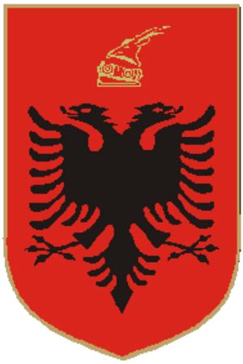
REPUBLIC OF ALBANIA

Annual Report
2017

www.asd.gov.al
t: +355 (4) 2362 989/2347 298
f: +355 (4) 2362 984
e: info@asd.gov.al
Rruga e Elbasanit, Nr. 317, Tiranë

TABLE OF CONTENT
Section 1 - Introduction 4
1. Message of the Chairman of the Board /General Director 4
2. Executive summary of the activity of the Agency 8
Section 2 – General overview of deposits 10
2.1.1. Eligible deposits in the banking system 11
2.1.2. Eligible individual deposits 15
2.1.3. Insured individual deposits 17
2.1.4. Eligible deposits of traders & companies 18
2.2. Deposits in Savings and Credit Associations 21
2.2.1. Eligible deposits 22
2.2.2. Insured deposits 24
Section 3 – Administration of funds and financial resources 26
3.1. Deposit Insurance Fund in Banks 26
3.1.1. Dynamics of the deposit insurance fund in banks 26
3.1.2. Main financial indicators of the deposit insurance fund in banks 26
3.1.3. Coverage ratio of the insured deposits in banks 28
3.2. Deposit insurance fund in Savings and Credit Associations 29
3.2.1. Dynamics of the deposit insurance fund in SCAs 29
3.2.2. Main financial indicators of the deposit insurance fund in SCAs 29
3.3. Administration of financial assets 32
3.4. Administration of financial resources 34
3.4.1. Loan agreements 34
3.4.2. Administration of the Resolution Fund 34
Section 4 - Main projects for the reporting year 35
4.1. Membership /introduction of SCAs to the deposit insurance scheme 35
4.2. Improving the Agency’s readiness for compensation 36
4.2.1. Agent Banks 36
4.2.2. Simulations with the Deposit Insurance Fund of Kosovo (DIFK) and FSVC Assistance Mission 37
5. Public awareness 40
6.1. Meeting of regional deposit insurers 44
Section 5 – Good governance 47
5.1. Board of Directors 47
5.2. Organizational Structure 48
5.2.1. Professional qualification and internal audit 49
Section 6 - Annexes 51
Annex 1 – Recommendations and implementation level of the Resolution of the Albanian Parliament 51
Annex 2 – Financial Statements 58

Section 1 - Introduction

Message of the Chairman of the Board /General Director
Dear readers,
We are pleased to report on another good year of progress of the Deposit Insurance Agency as we continue to reinforce good governance and readiness to fulfil our legal duties.
As in the previous years, we cannot fail to notice a recurrence of the challenges that have accompanied us in our work. Despite ongoing efforts, we are aware that there is always room for improvement. That is why we are constantly trying to raise our standards in all directions, especially in being ready for the compensation of insured deposits. As regulator and administrator of the deposit insurance scheme and at the same time as member of the financial safety network, public confidence in the banking and financial system is key to our activity. We are sure that the slightest decline in public confidence poses a risk to the fulfilment of our mandate. For this reason, we are fully committed to being transparent, objective and responsible.
Over the years, we have worked on our operational readiness, creating systems, infrastructures, policies and processes that will allow us to be more effective in fulfilling our mandate. These projects have also been maximally appraised with an award for the best deposit insurance system improvements conferred to the Agency by the International Association of Deposit Insurers (IADI).
We continually monitor and assess risks in our operational environment in order to be confident in preparing to compensate depositors in case of an insurance event in banking or non-banking institutions, members of the deposit insurance scheme. Another important link in this process is the Agent Bank that will be responsible for making payments to depositors in a compensation process on behalf of and for the account of the Agency. In this context, this year the Agency successfully developed and concluded the procedure for selecting three banks as its potential partners in carrying out the compensation process.
To test our readiness, we conducted and plan to conduct in the future, simulation exercises for a potential compensation process. In the past year, we conducted a simulation exercise in cooperation with our Kosovo counterpart, the Deposit Insurance Fund of the Republic of Kosovo (DIFK), from which we drew important lessons. For this year we have planned a similar exercise, in which the hypothetical compensation process of a member bank of the scheme will be simulated. The exercise will also include our agent banks selected from the preliminary list, which will also aim to prepare and test their capacities in case of such an event.
Year 2017 marked the first accession of the Savings and Credit Associations to the deposit insurance scheme, once the latter fulfilled the criteria for membership. The expansion of the scheme with subjects from the non-banking system is assessed as a positive performance in terms of strengthening the financial stability in the country, as one of the main objectives of the scheme. Another step for the fulfilment of this objective was the effective inclusion to the deposit insurance scheme of the deposits of traders and companies, at the beginning of 2017, in accordance with the legal provisions in force.
Throughout 2017, the Agency has also engaged in the fulfilment of the legal obligations stemming from the Law "On the Recovery and Resolution of Banks in the Republic of Albania", which assigns to the Agency, among others, the role of administrator of the Resolution Fund. In this context, ADIA has been part of working groups for drafting and implementing the relevant by-legal framework, in co-operation with the Resolution Authority (Bank of Albania). The Resolution Fund will be set-up in 2018 with the first annual contribution from banks.
Public confidence in the deposit insurance scheme has also been encouraged through public awareness and education initiatives, which have brought considerable progress over the years. The Agency has been engaged in raising the level of education and awareness of depositors about the benefits and limitations of the deposit insurance scheme, as well as their recognition of the compensation procedure through training and publication of promotional materials, social networking and communication through the official website.
In the international context, this year the Agency has intensified its relations with its counterparts and international organizations where it adheres, aiming to update the scheme according to the best standards in the deposit insurance field. We could highlight here the signing of a new co-operation agreement with the Deposit Insurance Fund of Kosovo, which enables a more practical and operational co-operation between our institutions, in order to develop mutual human capacities. This year, ADIA hosted the Balkan Regional Meeting of the European Forum of Deposit Insurers (EFDI) in Gjirokastra, with the participation of counterparts from Montenegro, Croatia, Serbia, Bosnia, Macedonia, Kosovo, Greece and Bulgaria. Like other meetings, this meeting was aimed at exchanging the recent experiences among deposit insurers of the abovementioned countries, taking into account the similarities of the respective financial and banking systems.
The challenges and risks faced by the banking and financial system are quite dynamic, therefore the difficulty in predicting them requires a flexible and tireless commitment and approach from the Agency. Like in the previous years, the need to be ready and prepared is constant for us. As the banking and financial environment develops, member institutions grow or diminish and their business models change, our mandate and demand to be prepared for the compensation of depositors remains the same. Along with protecting the interests of the depositors, the readiness for effective compensation, at the same time, protects the Albanian financial and banking system from potential systemic impacts.
In closing, we would like to thank colleagues and associates who share our goals and vision. In the future, we aim to better cope together the challenges and other unpredictable events that we may face. We are confident that through our strategy, the enthusiasm and dedication we engage in our tasks, we will be at every moment ready to face the challenges. In this context, we would like to emphasize the support of the members of the Board of Directors for their constructive criticism and the new perspectives they bring in to enhance the standards of the institution. We would also like to thank our national and international associates, in particular the Bank of Albania for its priceless support, as well as subjects member of the scheme and other strategic partners of the Agency for their contribution. We hope and trust in your co-operation in the future!
Donald Duraj | Genci Mamani
Chairman of the Board of Directors | General Director

Executive summary of the activity of the Agency
Year 2017 was characterized by a fluctuation of deposits in the banking system, with a small increase compared to the previous years. By the end of December 2017, the total deposits in the banking system reached 1,115 billion ALL, compared to 1,114 billion ALL a year earlier, marking an increase of 0.08%. The value of eligible deposits in banks benefiting from the deposit insurance scheme reached 1,074 billion ALL, 17.6% more than the previous year, mainly as a result of the expansion of the deposit insurance scheme with deposits from traders and companies at the beginning of 2017. The insured deposits for compensation in banks are 655.3 billion ALL, accounting for about 59% of the total deposits or 61% of the value of the eligible individual deposits. The value of deposits insured for compensation, which represent the obligation of the Agency to depositors in the banking system, increased with 43.9 billion ALL or 7% compared to the previous year.
By the end of 2017, the total deposits in the SCAs amounted to 6.1 billion ALL, from 4.1 billion ALL at the end of December 2016, marking an annual growth of 48.7%. The eligible deposits in the SCAs for 2017 are 6 billion ALL, marking an increase of 49.2% compared to the end of December 2016, and representing 98.6% of the total deposits. Deposits insured for compensation in SCAs are 4.5 billion ALL, accounting for 73% of the total deposits or 74% of the eligible deposits.
The financial performance of the Deposit Insurance Agency for 2017 is characterized by a stable growth of the deposit insurance fund in banks. On 31 December 2017, the book value of the deposit insurance fund in banks was 35.017 billion ALL or 12.08% higher than the previous year. Meanwhile, the book value of the deposit insurance fund at the Savings and Credit Associations in December 2017 was about 92.2 million ALL, marking an increase of 19.5% compared to 2016. The stable growth of the deposit insurance fund in banks has brought an increase of the coverage ratio, calculated as a percentage of the deposit insurance fund in banks compared to the insured deposits, at 5.34% at the end of 2017, from 5.11% in 2016, the year in which the 5% value was exceeded for the first time. Meanwhile, for the first year of the operation of the insurance scheme for Savings and Credit Associations, the coverage ratio of deposits in these companies is 2.05%.
Incomes from insurance premiums from banks for the reporting year were 3.2 billion ALL or 7.17% higher than the previous year. Meanwhile, incomes from insurance premiums from the SCAs for 2017 were 10.1 million ALL. Year 2017 was the first year the SCAs paid quarterly premiums to the Agency. Incomes from the administration of the financial assets of the deposit insurance fund in banks for 2017 were 780.2 million ALL. Incomes from the administration of financial assets of the deposit insurance fund in SCAs for 2017 were 1.3 million ALL or 16% more than in 2016. In 2017, the dynamics of incomes from the administration of financial assets were adversely affected by the dynamics of the interest rates, while they were positively affected by the diversification of the maturity of securities where it was invested.
Regarding the financial management of the ADIA funds, as one of the key success factors identified in the Strategic Plan 2015-2017, the structures of the Agency remain committed to the implementation of each year's budget with a fluctuation not greater than 10% from the approved budget, which requires drafting a budget both challenging and realistic. In drafting the budget for 2017, the Agency aimed for the current expenses for the year to be not higher than 25% of planned incomes from the administration of the financial assets. In relation to the total planned incomes these expenses were estimated at about 5%. It was estimated that keeping the expenses within these ratios would enable the fulfilment of the objectives as well as guarantee the expansion of the deposit insurance funds through net income throughout the year. The total incomes for the year ending on 31 December 2017 were realized at 99.53% compared to the plan for the year. The operational expenses of the Agency were realized to the amount of 83.23% compared to the plan.

Section 2 – General overview of deposits

During 2017, the Deposit Insurance Agency insured individual deposits in 16 banks of the system as well as in six Savings and Credit Associations. Year 2017 is the first year in which the deposit insurance scheme insured deposits of traders and companies in addition to individual deposits. Thus, by the end of 2017, the total of deposits in the financial system, including banks and SCAs, was 1,121 billion ALL. Depositors in each bank or branch of a foreign bank are insured to the amount of 100%, but in any case not more than 2,500,000 (two million five hundred and thousand) ALL, while depositors in Savings and Credit Associations are insured at 100 per cent, but in any case not more than 2,000,000 (two million) ALL, regardless of the number of deposits or type of currency deposited in the respective SCAs. The Agency, according to data for the end of 2017, has the obligation to compensate bank deposits to the amount of 655 billion ALL, or 1,655,605 depositors; as well as the obligation to compensate deposits to the amount of 4.5 billion ALL in Savings and Credit Associations, or 13,014 depositors. Out of the total obligation of 659.5 billion ALL of the Agency to depositors who have placed their deposits in banks and SCAs, 99.3% accounts for the obligation of the Agency to depositors who have placed their deposits in banks and 0.7% for the obligation to depositors who have their deposits in Savings and Credit Associations.
2.1. Deposits in the banking system
During the first half of 2017, the total deposits in the banking system had a downward trend with low monthly change rates, while during the second half of the year this trend was positive. By the end of December 2017, the total deposits in the banking system reached to 1,115 billion ALL, compared to 1,114 billion ALL a year earlier, marking an increase of 0.08%. The average annual change rate for the last ten years was 6.2%.

Graph 1. Dynamics of deposits in the banking system by the end of years 2002-2017

Eligible deposits in the banking system

At the beginning of 2017, the coverage range of the deposit insurance scheme expanded, including traders and companies. By the end of this year, the value of the eligible deposits benefiting from the deposit insurance scheme reached to 1,074 billion ALL, representing 96.3% of the total deposits. As a result of such expansion, the annual growth of the eligible deposits in value was 161 billion ALL or 17.6% more compared to the value of 913 billion ALL of the eligible individual deposits at the end of the previous year. The eligible deposits include current accounts, card accounts, savings accounts, time deposits, joint accounts and other similar products.
The eligible deposits in ALL at the end of December 2017 account for the largest share of the total eligible deposits of 48.73%, followed by deposits in Euro 43.7% and deposits in USD 5.7%.
According to the definitions of Law No. 53/2014 "On Deposit Insurance", as amended, the amount of compensation is paid up to the maximum coverage level, only if it exceeds the value of 100 ALL.
Deposits for compensation in the banking system by the end of 2017 reached 655.3 billion ALL, representing the Agency's maximum obligation vis-à-vis 1,655,605 individual depositors, traders and companies.
Graph 2. Structure of the amount of the eligible deposits in system according to currencies in % - 31/12/2017

The dynamics of the eligible deposits in ALL during 2017 has been both positive and negative, with relatively small monthly change rates. The highest monthly change rate was 2.4% at the end of December. During this period, deposits reached a value of 523.3 billion ALL. The eligible deposits in foreign currency account for 51.27% of the total eligible deposits, and their counter value in ALL is 550.6 billion ALL. Most part of 2017 was dominated by the positive dynamics of the foreign currency deposits, while the highest monthly change rate was recorded by the end of August with 2.4%.

Graph 3. Dynamics of the eligible deposits in the system according to the currencies during 2017

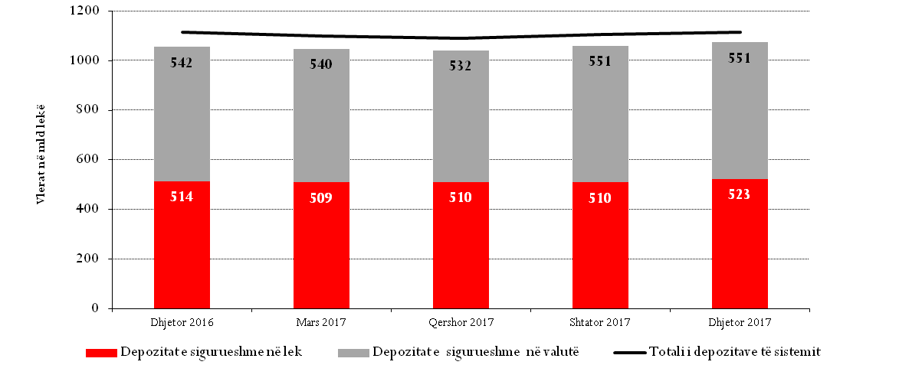
Dec 2017
Sep 2017
Jun 2017
Mar 2017
Dec 2016
Total of system deposits
Eligible deposits in Foreign Currency
Eligible deposits in ALL

By the end of December 2017, the eligible deposits of less than or equal to the maximum level of coverage were 407 billion ALL (expressed as a percentage, 38% of the total amount of the eligible deposits), while deposits over the maximum level of coverage reached to 667 billion ALL (or 62% of the total amount of the eligible deposits).

Graph 4. Structure of the eligible deposits for compensation compared to the coverage limit of 2.5 mln ALL, December 2017
418.4
248.6
Eligible deposits up to the maximum level of coverage
Eligible deposits over the maximum level of coverage
Insured individual deposits up to the maximum level of coverage
Insured individual deposits above the maximum level of coverage
Uninsured deposits
667.1
406.6
406.6
Eligible deposits for
compensation
=
1,073.7 billion ALL
2.5 mln
ALL
Compared to the maximum
level of coverage

Uninsured deposits
(billion ALL)
Insured deposits
= 655.3 billion ALL

Eligible individual deposits

On 31 December 2017 the eligible individual deposits in the banking system reached 922.9 billion ALL, accounting for the largest share of the total eligible deposits, namely 86% (the annual change rate was + 1.1%).
The greatest impact on the annual growth of the eligible individual deposits was from deposits in foreign currency, which increased faster than deposits in ALL. In December 2017, deposits in foreign currency expressed in their countervalue in ALL had a weight of 50.3% and an annual growth of + 2%, while the annual growth of deposits in ALL was 0.2%. Deposits in USD (their weight was 5.4%) marked an annual growth of 24.5%, while their countervalue in ALL grew by 8%, while deposits in EUR (their weight was 42.8%) marked an annual growth of 2.3%, whereas their countervalue in ALL grew by 0.5%.
By the end of December 2017, the eligible individual deposits in ALL in the banking system reached an amount of 459 billion ALL, representing 49.7% of the individual deposits, while compared to the previous year they marked a growth to the amount of 858 mln ALL.
Graph 5. Structure of the amount of the eligible individual deposits in the system according to currencies in %-December 2017

According to the level of coverage, the increase with 2.8% of the deposits amounting from 101 - 2.5 million ALL, had the greatest impact on the annual growth of the eligible individual deposits. These deposits have a weight of 42.5% (the annual change of deposits with amounts above the coverage level of 2.5 mln ALL was -0.1%) in the total of eligible deposits.
Compared to the end of 2003, which was the first year of full activity of the deposit insurance scheme in Albania, the value of the eligible individual deposits in the banking system increased 3.3 times in nominal terms.
The number of individual depositors holding these deposits by the end of 2017 was 2,479,471. The number of individual depositors benefiting compensation in the banking system during the 15-year period of the activity of the deposit insurance scheme has increased 6.2 times (from 400,000 depositors at the beginning of 2003 to 2,479,471 in December 2017).

94% or 1,469,059 depositors, out of individuals with deposits larger than 100 mln ALL, have deposits up to the coverage level and benefit a full coverage from the insurance scheme.
Eligible deposits larger than 2.5 million ALL decreased by 765 million ALL or 0.1% compared to the previous year, reaching by the end of December 2017 a value of 531 billion ALL. These deposits belong to 92,818 depositors.

Graph 6. Dynamics of the number of individual depositors classified according to the level of coverage 2009-2017
Insured deposits are part of eligible deposits up to the maximum level of coverage, according to the stipulations made in Law No. 53/2014. "On Deposit Insurance", as amended.
By the end of 2017 the insured individual deposits in the banking system increased with 12.6 billion ALL or 2.1% compared to the previous year.

Graph 7. Dynamics of eligible and insured individual deposits 2012-2017
Individual insured deposits
Individual eligible deposits

Insured individual deposits
By the end of December 2017 the insured individual deposits in the banking system had a value of 624 billion ALL and accounted for 67% of the value of the eligible individual deposits.
Graph 8. Dynamics of the insured individual deposits in value and the annual change in % 2009 – 2017

Graph 9. Dynamics of the insured individual deposits in value during 2017
For the period 2009-2017, the percentage of individual deposits with a value up to 2.5 million ALL varied from 40% to 48% of the total eligible deposits.
Graph 10. Dynamics of the individual deposits classified according to the level of coverage 2009-2017

Eligible deposits of traders & companies
In December 2017, these deposits in the banking system reached 151 billion ALL, marking an annual growth of 5.3%. The biggest impact in the annual growth was from deposits with amounts above 6.5 million ALL, specifically by 5.93%. These deposits also have the greatest share in the total eligible deposits, specifically 81.3%.
According to the currency type, the greatest impact on the annual growth of 5.3% of the eligible deposits of traders and companies was from deposits in ALL, which in December 2017 accounted for 42.6% of the total deposits. The annual change rate for deposits in ALL was + 15.1%. Deposits in foreign currency, expressed in their countervalue in ALL, decreased by 0.96% compared to the previous year. Deposits in Euro have the greatest share of deposits according to the currency: 49%, which expressed in their countervalue in ALL decreased by 2.06% compared to the previous year, while deposits in USD were 8% and expressed in their countervalue in ALL increased by 3.85% compared to the previous year.

Graph 11. Structure of the eligible deposits of traders and companies in the system according to currencies in % - December 2017

According to the category of products, current accounts occupy the greatest share of the eligible deposits for traders and companies with 87%.
Unlike the situation of the eligible individual deposits, 90% of the deposits of traders and companies are in excess of the coverage level and correspond to 6,626 depositors, representing 5% of traders and companies. The current structure has maintained these ratios throughout 2017.
The insured deposits of traders and companies increased by 4.1% throughout 2017 and by the end of this year they reached a value of 31.4 billion ALL. The dynamics of the insured deposits of traders and companies throughout 2017 has been both positive and negative.

Graph 12. Dynamics of the insured deposits of traders and companies in value during 2017

Deposits in Savings and Credit Associations

Deposits in Savings and Credit Associations during the first year of accession into the deposit insurance scheme have experienced a constant monthly increase of 2.1%, except for July, with an increase of 18.2%. The increase came as a result of the membership of the Savings and Credit Association "UniFin" to the scheme, in July. By the end of 2017, the total deposits of the Savings and Credit Associations reached 6.1 billion ALL, from 4.1 billion ALL at the end of December 2016, marking an annual growth of 48.7%.

Graph 13. Dynamics of the SCAs deposits during 2017

Eligible deposits
The eligible deposits by the end of December 2017 were 6 billion ALL, representing 98.6% of the total deposits, versus 4 billion ALL as of December 31, 2016. They go to the benefit of 19,543 depositors of the Savings and Credit Associations, versus 5,879 depositors benefiting from the scheme as of December 31, 2016. In 2017 the number of depositors increased by 232%. This significant increase was not only a result of the expansion of the activity of the existing Savings and Credit Associations, but also a result of the involvement of “UniFin" in the scheme.
“Eligible deposits in SCAs include time deposits as well as support accounts of depositors / members of SCAs.”

By the end of December 2017 the eligible deposits increased by 49.2% compared to the end of December 2016. The greatest impact in the annual growth of the eligible deposits was from the increase of deposits in ALL.
Graph 14. Total deposits according to the currencies 31 December 2017

Deposits in ALL account for the greatest share of the total eligible deposits of SCAs. Their annual growth is 43.5%. Only some of the SCAs accept deposits in foreign currency, keeping at low levels the ratio between the specific weight of deposits and the total of eligible deposits.
Graph 15. Structure of the eligible deposits for compensation compared to the coverage limit of 2 mln ALL in December 2017

1.5 bn
2.2 bn
Eligible deposits for compensation up to the maximum level of coverage
Eligible deposits for compensation above the maximum level of coverage
Deposits for compensation of depositors with deposits up to the maximum level of coverage
Deposits for compensation of depositors with deposits above the maximum level of coverage
Uninsured deposits
3.7 bn
2.3 bn
2.3 bn
Eligible deposits
for
compensation
6 bn
ALL
2 mln
ALL
Compared to the maximum
level of coverage

Uninsured deposits
( bn ALL)
Deposits for compensation
= 4.5 bn ALL

Insured deposits
By the end of 2017, deposits insured in Savings and Credit Associations were 4.5 billion ALL. This amount represents 73% of the total deposits or 74% of the eligible deposits.
Graph 16. Dynamics of the insured deposits according to the quarters of the first year of activity

By 31 December 2017, the insured deposits fully covered by the deposit insurance scheme and less than 2 million ALL (all deposits between 101-2 million ALL) reached an amount of 2.3 billion ALL, accounting for 38% of the total eligible deposits.
Deposits partially covered by the deposit insurance scheme and greater than 2 million ALL, reached an amount of 3.7 billion ALL on 31 December 2017, accounting for 62% of the total eligible deposits.
Graph 17. Dynamics of the insured deposits versus the total eligible deposits according to the coverage level, expressed in %

Graph 18. Dynamics of the insured deposits according to the level of coverage

The number of depositors with deposits up to 2 million ALL by the end of December 2017 was 11,935. They make up 92% of the total number of depositors benefiting from the deposit insurance scheme. The number of depositors with deposits in excess of 2 million ALL by the end of December 2017 was 1,079, accounting for 8% of the total number of depositors benefiting from the scheme.
Graph 19. Number of the insured depositors throughout 2017 (3-month change)
Number of > 100 <2 mln ALL insured depositors with deposits > 100 <2 mln ALL
Number of insured depositors with deposits over 2 mln ALL

Section 3 – Administration of funds and financial resources

Deposit Insurance Fund in Banks

Dynamics of the deposit insurance fund in banks
As of December 31, 2017, the book value of the deposit insurance fund in banks, which consists of a start-up capital of 400 million ALL and accumulated profits over the years, is 35.017 billion ALL. Compared to the previous year, the fund has increased by about 3.7 billion ALL or 12.08%. The following graph shows the dynamics of the deposit insurance fund for the period 2009 - 2017.
Graph 20. Deposit insurance fund in banks (in thousand ALL)

Main financial indicators of the deposit insurance fund in banks
The size of the deposit insurance fund in banks is determined by the net income from the activity over the years. The main incomes contributing to the increase of the deposit insurance fund in banks are incomes from the insurance premiums and those from the administration of the financial assets.
According to the Law "On Deposit Insurance", starting in 2015, the premium for deposit insurance is calculated on a quarterly basis instead of yearly basis. The quarterly insurance premium for banks is calculated as 0.125% of the arithmetic average of the amount of the insured deposits that have been registered in the bank on the last day of each month of the previous quarter, while the quarterly insurance premium for SCAs is calculated as 0.075% of the arithmetic average of the amount of secured deposits that have been registered in the SCAs on the last day of each month of the previous quarter. The quarterly insurance premium for subjects member of the insurance scheme is paid no later than the 15th of the first month of the quarter for which it is paid.
Incomes from the insurance premiums for 2017 were 3.2 billion ALL or 7.17% higher than in 2016. Incomes from the insurance premiums over the period 2009 - 2017 have been increasing, which is directly related to the increase of the insured deposits in the banking system in these years.
Graph 21. Insurance premiums in banks (in thousand ALL)

Incomes from the administration of the financial assets of the deposit insurance fund in banks for 2017 were 780.2 million ALL or 0.3% less than in 2016. Over the period 2009-2013 these incomes have increased, which is directly related with the expansion of the financial assets under administration and the interest rates on securities. Incomes from the administration of financial assets for the years 2014-2017 were affected by the reduction of the interest rates of the Albanian Government securities. In 2017, the dynamics of the incomes from the administration of the financial assets was adversely affected by the dynamics of the interest rates and positively affected by the diversification of the maturities of securities, where it was invested.

Graph 22. Incomes from the administration of the financial assets of the deposit insurance fund in banks (in thousand ALL)

Coverage ratio of the insured deposits in banks
By the end of 2017, the insured deposits in the banking system were 655.4 billion ALL or 7.2% higher than the previous year. The stable growth of the deposit insurance fund in banks and the more moderate performance of the insured deposits in the banking system throughout the period 2009 - 2017 have led to a steady increase in the coverage ratio over the years. By the end of 2017, the coverage ratio, calculated as a percentage of the deposit insurance fund in banks compared to the insured deposits was 5.34%. The graph below shows a summary of the dynamics of the insured deposits in the banking system and the coverage ratio over the years 2009 - 2017.
Graph 23. Coverage ratio and insured deposits in banks (in thousand ALL)
By the end of 2017, for the second consecutive year, the coverage ratio reached over 5% of the insured deposits since the creation of the Deposit Insurance Agency. The realization of this objective, as an indicator included under the Law “On Deposit Insurance”, is important for the efficiency of the scheme to meet the obligations to depositors and the positive performance of the deposit insurance fund in banks over the years.

Deposit insurance fund in Savings and Credit Associations

Dynamics of the deposit insurance fund in SCAs
According to the Law “On Deposit Insurance”, as amended, in January 2015, the State Budget received the start-up capital for the deposit insurance in SCAs, to the amount of 76 million ALL. The fund provided the initial financial base of the deposit insurance fund in SCAs. Starting from 2015 and onwards until 2017, the Agency has administered the financial assets of the deposit insurance fund in SCAs, which entered the scheme in January 2017. On 31 December 2017, the book value of the deposit insurance fund in SCAs, which consists of the start-up capital of 76 mln ALL, and accumulated incomes and premiums, was about 92.2 million ALL, marking an increase of 19.5% compared to 2016 and an average growth of 3.7% throughout 2017.
Graph 24. Deposit insurance fund in SCAs (in thousand ALL)

Main financial indicators of the deposit insurance fund in SCAs
The main incomes contributing to the growth of the deposit insurance fund in banks are incomes from the insurance premiums and those from the administration of the financial assets.
According to the legislation in force, subjects that were admitted to the scheme in January 2017 started to pay their quarterly insurance premiums. Meanwhile, another subject included in 2017, paid an initial contribution to a value of 1.1 million ALL.
Since 2017 was the first year of the operation of the insurance scheme for these companies, information on the dynamics of the financial indicators for 2017 is presented below.
Incomes from the insurance premiums throughout 2017 were 10.1 million ALL. These incomes have increased from quarter to quarter throughout 2017, which is directly related to the increase of the insured deposits in these companies in 2017.
Graph 25. Dynamics of the quarterly premiums of deposit insurance in SCAs (in thousand ALL)

Incomes from the administration of the financial assets of the deposit insurance fund in SCAs throughout 2017, compared by quarters, were as follows.
Graph 26. Incomes from the administration of the financial assets of the deposit insurance fund in SCAs (in thousand ALL)

As far as concerns the coverage ratio of deposits in these associations throughout the first year of the operation of the scheme, it is represented in the following graph.
Graph 27. Coverage ratio and insured deposits in SCAs (in thousand ALL)
SCA Insured Deposits
Coverage Ratio

Administration of financial assets
As of December 31, 2017, the financial assets of the Agency, with a book value of 35,017 billion ALL, were all invested in Albanian Government’s securities. In order to effectively manage the financial assets and guarantee at any time the needs for liquid financial assets, the Agency, according to the investment policy, maintains 11 percent of its portfolio in highly liquid instruments, such as deposits with the Bank of Albania or securities which mature not later than 90 days from the moment of purchase by the Agency. The following graph represents a summary of the financial assets of the Agency by type of instruments, as of 31 December 2017.

Graph 28. Financial assets according to the type of instruments
2 - 10 years
3 - 24 months
Liquidity tranche
The financial assets of the Agency are mostly in ALL. The Agency also maintains a portion of its financial assets in Euro currency. In line with the Investment Policy, investments in foreign currency account for 9 percent of the financial assets under administration, and the long-term plan aims at approaching the structure by currency type for the portfolio of the Agency with that of the insured deposits. The following graph represents a summary of the financial assets of Agency by currency, as of 31 December 2017.
Graph 29. Financial assets by currency
The following graph shows the distribution of the financial assets by duration up to maturity, on 31 December 2017. In order to effectively manage the financial assets and guarantee at any time the needs for liquid financial assets, they are allocated in escalated way by duration up to maturity. Following the adoption of Law no. 53/14 "On Deposit Insurance", the Agency has moved about 23% of its portfolio in instruments with residual maturity of 24 months and about 12% of its portfolio in instruments with residual maturity over 24 months.
Foreign Currency
ALL
Graph 30. Financial assets by duration up to maturity
More than 24 months
12 to 24 months
9 to 12 months
6 to 9 months
3 to 6 months
Up to 3 months
Liquidity tranche

Administration of financial resources

3.4.1. Loan agreements
The Law on Deposit Insurance, in accordance with the core principles and best practices in the field of deposit insurance, has provided the Agency with the ability to address different financial resources in order to guarantee at all times the fulfilment of its obligations. One of the most important instruments available to the Agency is the right to borrow.
In the end of 2014, the Agency signed a loan agreement with the European Bank for Reconstruction and Development (EBRD) for a credit line up to EUR 100 million. The loan agreement is accompanied by a guarantee of the Albanian Government. Under the agreement, the Agency pays an annual commission for its commitment to this instrument, as much as 0.5% of the available amount from the line of credit. In case of an insurance event, the Agency may access the available funds from the line of credit in a short time, thus increasing the efficiency of the scheme to respond in time to liabilities towards depositors. At the Agency's request, the amount available from the line of credit decreases at no cost when the funds of the Agency and the coverage ratio from these funds increase. During 2017, as a result of the increase in coverage ratio, the Agency lowered the available amount from the line of credit from EUR 58 million to EUR 41 million, which also affected the reduction of financial expenses for this instrument compared to the previous year. The Ministry of Finance, in the capacity of the guarantor, was informed and acquainted with this reduction.

3.4.2. Administration of the Resolution Fund
By Law No. 133 / 2016, dated 22.12.2016, "On Recovery and Resolution of Banks in the Republic of Albania", the Deposit Insurance Agency has been assigned powers to administer this fund. For this reason, the Agency has drafted the Financial Assets Management Policy document for this fund and submitted it for approval to the Resolution Authority. The fund will start to be effective at the beginning of 2018.

Section 4 - Main projects for the reporting year

Membership /introduction of SCAs to the deposit insurance scheme

January 1, 2017, marked the effective introduction into the deposit insurance scheme of five SCAs, which correctly and timely fulfilled all the criteria for membership. Year 2017 was their first year of activity as members of the deposit insurance scheme.
On 20 July 2017, the Board of Directors of the Agency decided to include UniFin to the deposit insurance scheme. UniFin was created as a result of the transformation of Jehona Union and its merging with the SCA "New Cred". The decision of the Board of Directors to expand the scheme with this new association came only after a complete verification process on completion of the documentation in accordance with the requirements of Directive No. 4188, dated 01.09.2016, "On Deposit Insurance in Savings and Credit Associations", as well as verifications on meeting the criteria, in accordance with the legal and regulatory framework in force.
At the end of 2017, six SCAs members of the deposit insurance scheme were reported. This year has signed an increase in deposits and number of depositors in all the Savings and Credit Associations member of the scheme. The number of depositors in all SCAs at the end of this period was 19,500, while the total of deposits was about 6 billion ALL.
The Agency, throughout the year 2017, has closely followed the performance of the savings and credit associations, both through training meetings and verifications. Training meetings and verifications aimed at a prudent growth of the Savings and Credit Associations, the promotion of their healthy and long-term business, as well as the correct implementation of the legal framework in force.
During 2017, the Agency has conducted two complete verifications in all SCAs. The first round of verifications was conducted during February-March, while the second round was conducted in September. The recommendations left in the verification reports were aimed at the correct implementation of Law No. 53/2014, dated 22.5.2014, "On Deposit Insurance", as amended, as well as Directive No. 4188, dated 1.09.2016, "On Deposit Insurance in Savings and Credit Associations".
By the end of the first year of their activity as members of the deposit insurance scheme, it is estimated that SCAs have generally implemented the recommendations left in the verification reports of the Agency and their performance is positive.

4.2. Improving the Agency’s readiness for compensation

4.2.1. Agent Banks
Pursuant to its legal obligation, in 2017 the Deposit Insurance Agency conducted the first stage of the procedure of selection of the agent banks from the preliminary list. The procedure is a key link throughout the entire chain of preparatory measures for the compensation process. The final goal of the process is the selection of the agent bank, which will conduct the payments of compensation on behalf of and for the account of the Agency, in case a subject member of the scheme is placed under compulsory liquidation by a decision of the Bank of Albania.
The selection process of the Agent Bank was conducted in two phases: i) the first phase is the evaluation of the banks member of the scheme, according to the general and technical criteria adopted in the Regulation no. 3762, dated 18/7/2016 "On Deposit Compensation"; ii) the second phase is the evaluation of the economic offers of banks selected from the preliminary list, in case a subject member of the scheme is placed under compulsory liquidation by a decision of the Bank of Albania. The selection of the agent banks from the preliminary list took place during the day-to-day operation of the Agency, in view of its operational readiness. At this stage, the Agency selected a preliminary list of no more than three banks member of the scheme, which met the general criteria and received the highest scores in the evaluation of the technical criteria.
The Agency initiated the selection procedure by sending an invitation for expression of interest to all the banks member of the deposit insurance scheme. The banks expressed their interest and extensively participated in the process.
As the procedure was taking place for the first time, the Agency organized consultative meetings with bank representatives. These meetings preceded the evaluation process for the expressions of interest. Throughout the process, the Agency cooperated closely with the Supervisory Authority, particularly in the process of the evaluation of the qualification criteria for the banks.
Upon completion of the evaluation process, the Board of Directors of the Agency, by its Decision No. 23, dated 03/10/2017, "On the selection from the preliminary list of agent banks for the compensation process", selected three agent banks from the preliminary list. The Agency negotiated and signed contracts with all three selected agent banks.
The co-operation of the Agency with the selected agent banks will continue with the organization of trainings and simulations in order to test their level of readiness and improve the professional capacities needed to fulfil the legal mandate of the Agency.

Simulations with the Deposit Insurance Fund of Kosovo (DIFK) and FSVC Assistance Mission
The organization of simulations of the compensation process is an important part of the projects under the Strategic Plan of the Agency, with a view to enhancing the professional skills of the staff of the Agency, improving the level of readiness and necessary professional capacities of both the Agency and its partners, in case of an insurance event. In view of the implementation of this strategic objective, the Agency has co-operated with counterpart agencies, and relied on the technical assistance provided by specialized international institutions.
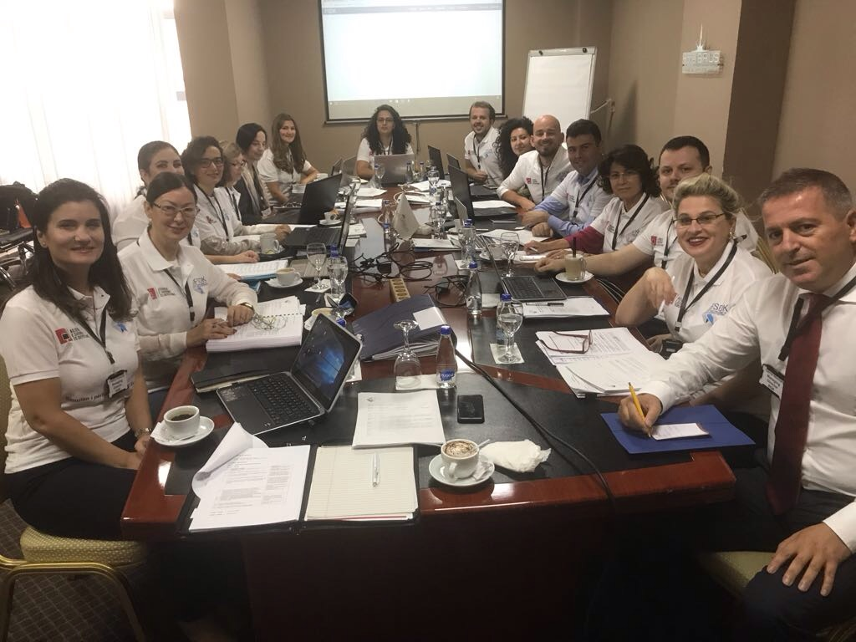
Specifically, the Agency co-operated with the Deposit Insurance Fund of the Republic of Kosovo in the conduct of a joint simulation for the compensation process, which took place in Pristina, on 28 and 29 September 2017. The simulation was aimed at increasing the professional capacities and exchanging experience between the two institutions. The theme of the simulation was "Simulation of the Compensation Process: Preparatory and Compensation Phase". Such an exercise activity was organized for the first time at regional level, after a two-month period of preparations by both institutions.
According to the scenario prepared and agreed in advance between the two institutions, the simulation exercise was conducted in two phases. Phase I, simulation of the preparatory phase and phase II, simulation of the compensation phase. In the first phase, the teams of both agencies worked in the table, while in the second phase the exercise continued in the premises of the bank selected as the Agent Bank, to carry out with the compensation pay-outs.
At the end of this activity, both institutions highlighted the issues that needed to be improved in the future, in view of the prompt and accurate performance of a compensation process. The parties also agreed to conduct a technical simulation in Tirana, concerning the functioning of the insurance premium calculation module.
The Joint Technical Simulation between the Albanian Deposit Insurance Agency and the Deposit Insurance Fund of Kosovo on the process of the premium calculation was conducted in Tirana, on 05 October 2017. The main purpose of the simulation was to estimate the accuracy of the calculation of periodical premiums through the Agency’s IT System on Reporting and Compensation. In the course of the process, flawed reports were simulated with the purpose of evidencing them in the system and further correcting them from the subject under simulation.

Also on 13-17 November 2017, the Deposit Insurance Agency, with the support of experts from the Financial Services Volunteer Corps (FSVC), conducted in its premises a weekly activity "On the simulation exercise for compensation of insured deposits", with the aim of preparing different simulation scenarios. The experts advised the Agency and provided support for the internal procedures related to the organization and conduct of simulations.
This was the next FSVC project, in the framework of a program on strengthening the institutional capacities of the Agency. The activity was funded by the United States Agency for International Development (USAID).
All these activities contributed to strengthen the professional efficiency and readiness of the Agency to carry out a compensation process.

Public awareness
Stability of the financial system is an important component for a healthy economy and contributes directly to the development and growth of the country's economy. One of the pillars of a sound financial system is the deposit insurance system and public confidence in the system. Given the above, the Deposit Insurance Agency has intensified its work to increase the level of public awareness in relation to the insurance scheme as well as the role and functions of the Agency as a contributor to the financial stability of our country.
The promotional activity of the Agency during 2017 continued to be guided by the ADIA’s Strategic Plan 2015-2017 and the Public Awareness Strategy, documents that clearly define the objectives, principles, tools and methods the Agency should pursue in order to successfully and efficiently fulfil its legal mandate for the administration of the deposit insurance scheme, both in quiet times and in case of an insurance event.
Throughout 2017, the Agency focused on developing and expanding its co-operation with target groups, respectively with subjects member of the scheme, depositors, regulatory subjects of the domestic financial market and the general public.
Public information on time, in consistent and transparent way. Given the legal framework, the Agency has estimated that the variety and combination of its communication tools and methods in quite times will influence to reach depositors and stakeholders quickly in case of a bankruptcy event.
Thus, during 2017, the Agency continued to distribute for free promotional leaflets with key information on the deposit insurance scheme. The leaflets were designed with new display and content, illustrated with examples, with a view to providing clear, comprehensible and transparent information. The official logo of the Agency is displayed at counters and main entrances of banks / savings and credit associations, in order to transmit the safety of the eligible deposits to depositors in banks and associations. The Agency has also prepared a contract annex for depositors with complete information on insuring their deposits.
The official website of the Agency is another channel of information and communication with depositors and stakeholders. All the information, announcements and activities related to the operations of the Agency are reflected in real time and transparently. On the web, any interested person can get information on important arrangements / meetings / participation, with a view to the institutional development and expansion. Another important section is the presentation of activities not only in view of public awareness but also of the development of the deposit insurance scheme, such as conducting the "Simulation Exercise for Compensation of Insured Deposits", open lectures with university students, holding the "5th Regional Meeting of the Balkan countries", etc.
The Agency's profile on social networks used as another effective means of public information and education has continued to develop with the same dedication as the official website of the Agency. There has been a more interactive approach with the stakeholders, depositors and beyond. Corresponding with the users through comments and questions has given the Agency the opportunity to better assess public perceptions of the scheme and the institution. In addition, the Agency has oriented depositors towards accurate information, to take advantage of the benefits of the scheme, take care of its limitations as well as clarify the wrong perceptions and prevent false information.
Meetings with stakeholders at the premises of the Agency is another indicator of raising public awareness and education about the deposit insurance scheme. Depositors of various levels and requests prefer to specify their information at the offices of the Agency. The interactive communication and the accuracy and transparency of transmitted information have enabled the Agency to not only successfully inform but also influence on increasing confidence in the deposit insurance scheme in particular and the banking and financial system in general.
During this time frame/year, special importance has been given to co-operation with banking and financial institutions in the country and participation in financial education campaigns. After many years of experience in trainings and seminars with employees and managers of subjects member of the scheme, this year the Agency has given an important role in its institutional plan to the information and education of the young generation. Access to this target group is considered to be essential not only to transmit basic knowledge but also to understand the functioning of the deposit insurance scheme and its impact on the banking and financial market in the country. In this context, the Agency participated in the activities conducted during the Global Money Week 27 March - 2 April 2017, a worldwide celebration aimed at raising the awareness of the young generation to be responsible and financially capable citizens in the future, an activity which has now become a tradition in our country too. In some of the activities, the Agency was able to communicate directly with high school pupils and students and distribute some of its promotional materials. Fully efficient were also the open lectures with students from public and private universities of Tirana, banking-finance branch. Co-operation and coordination with university structures has been satisfactory and of mutual interest. This was evidenced not only by their large participation but also by the quality of their questions and demands for information.
6. Development of the regional co-operation
6.1. New burst in bilateral relations with the Deposit Insurance Fund of Kosovo (FSDK)
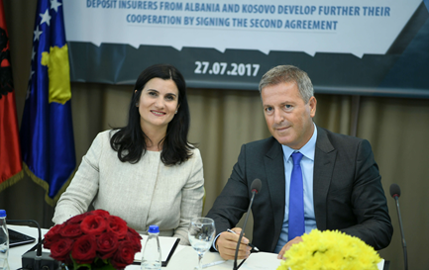
The need to increase the level of co-operation between the Deposit Insurance Agency of the Republic of Albania and the Deposit Insurance Fund of Kosovo was identified in mutual and continuous meetings between the respective authorities, carried out under the Memorandum of Understanding, signed in June 2014. To this end, after intensive consultations, on 27 July 2017, the Executive Directors of ADIA and FSDK, Mr. Genci Mamani and Mrs. Violeta Arifi-Krasniqi respectively, signed the new Memorandum of Understanding in Pristina.
This very important document, which as shown in the previous sections of this Report was implemented immediately after its signature, aims to increase the professional level as well as the insuring and compensating capacities of both institutions. The new Memorandum of Understanding aims primarily at creating spaces for more professional and inclusive co-operation in terms of preparing for a compensation event. The Signatory Authorities engage to conduct joint simulation exercises and provide mutual assistance, if deemed necessary, in the events of compensation.
This further development of the level of co-operation between the Deposit Insurance Agency of the Republic of Albania and the Deposit Insurance Fund of Kosovo is estimated to be very fruitful considering the similar organizational structures and financial realities, and the emphasis placed on the cross-border cooperation in the Core Principles for Effective Deposit Insurance Schemes (IADI Core Principles) and the European Directive on Deposit Insurance Schemes.

Meeting of regional deposit insurers
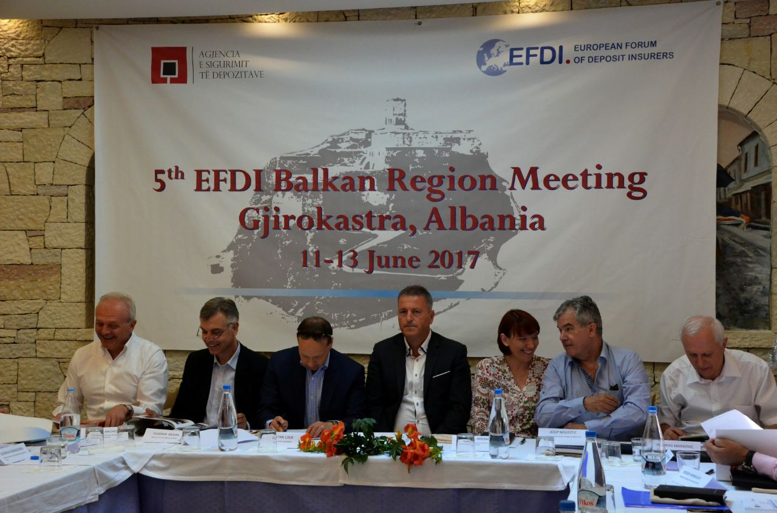
During 2017, the Agency has continued to pay particular attention to the promotion and further development of the mutual co-operation with counterpart agencies in the region. In this framework, from June 11 to June 13, 2017, in Gjirokastra was organized the 5th EFDI Balkan regional meeting. The European Forum of Deposit Insurers (EFDI) is the European organization of deposit insurers, to which the Agency adheres. EFDI contributes to the stability of the financial systems through the European and international co-operation in the field of deposit insurance, crisis resolution, exchange of experiences and information, etc. EFDI also engages in consultations on the European regulatory instruments with the European Union institutions, in particular the Directive on Deposit Guarantee Schemes.
Gjirokastra meeting took place in the wake of an ongoing tradition of meetings of the deposit insurance authorities of Albania, Bosnia and Herzegovina, Croatia, Macedonia, Montenegro and Serbia, where recent experiences and tendencies in the regional deposit insurance spectrum are discussed and exchanged. Challenges, prospects, issues of common interest, etc., summed up the issues discussed by the executive directors of the deposit insurance institutions, with particular emphasis on the recent developments in each jurisdiction, compensation cases, financial stability dialogue within the respective safety networks, the role of deposit insurers in the context of the resolution initiatives and relations with supervisory authorities in this respect.

With an the invitation from the Deposit Insurance Agency, EFDI Deputy Chairman and General Director of the Swiss Deposit Insurance Scheme attended the meeting and presented to all participants the latest amendments to the EFDI Statute and changes within the EFDI organizational structure, as well as the future projects aimed at strengthening the organization and its members. Also attending the meeting, with the invitation of the Deposit Insurance Agency, were the Director of the Hellenic Deposit and Investment Guarantee Fund (TEKE), the Managing Director of the Deposit Insurance Fund of Kosovo (DIFK), and the Bulgarian Deposit Insurance Fund (BDIF).

Section 5 – Good governance

Board of Directors
The Board of Directors is the highest decision-making organ of the Deposit Insurance Agency. The Board of Directors is responsible for the performance and well-functioning of the activities and operations of the Agency. Its members have the obligation to act always honestly in the best interest of the Agency. The role of the Board focuses on its oversight responsibilities, acting independently and assessing the performance of the management of the Agency in response to legal requirements, recommendations of the constitutional institutions (the Assembly of the Republic of Albania) and supervisors institutions (Bank of Albania), to which the Agency reports, as well as objectives set out in the strategic plans and other acts of the Agency.
The members of the Board of Directors are non-executive, with the exception of the member who is appointed to the position of the General Director. The term of office for each member of the Board of Directors is five years, with a right to re-election, based on the performance indicators of their activity.
The Board of Directors is composed of five members appointed by the Supervisory Authority and proposed as follows:

BOARD OF DIRECTORS | ROLE | PROPOSING INSTITUTION
Donald Duraj | Chairman | Bank of Albania
Genci Mamani | Member | Bank of Albania
Erjon Luçi | Member | Minister of Finance
Ervin Mete | Member | Minister of Finance
Nexhmije Çela | Member | Authorized Countable Experts Institute (ACEI)

The activity of the Board of Directors for 2017 was exercised in accordance with the competences defined in the Law on “Deposit Insurance”, as amended, the Statute of the Deposit Insurance Agency, the Regulation "On the rules and procedures on functioning of the meetings of the Board of Directors of the Deposit Insurance Agency" and the legislation in force on collegial bodies.
In 2017 the Board of Directors held monthly meetings followed by the relevant decision-making (36 decisions) in order to establish and maintain the high standards of the good governance and consolidate the capacities of the Agency to fulfil its legal mandate. The decision-making of the Board focused mainly on the adoption of by-legal acts for the purpose of good administration and expansion of the deposit insurance scheme, and the operational progress of the Agency.

Organizational Structure
The Deposit Insurance Agency operates according to the organizational structure approved by Decision of the Board of Directors No. 19, dated 29/08/2013, "On the approval of the organizational structure, chart and number of employees of the Deposit Insurance Agency", as amended.
According to the organizational structure, the Agency has a Board of Directors which selects the General Director who runs the Agency. The Agency is composed of 7 sectors and has a staff of 29 employees. In 2017, the Agency was characterized by a stable ongoing staff, following its policies of professional motivation.
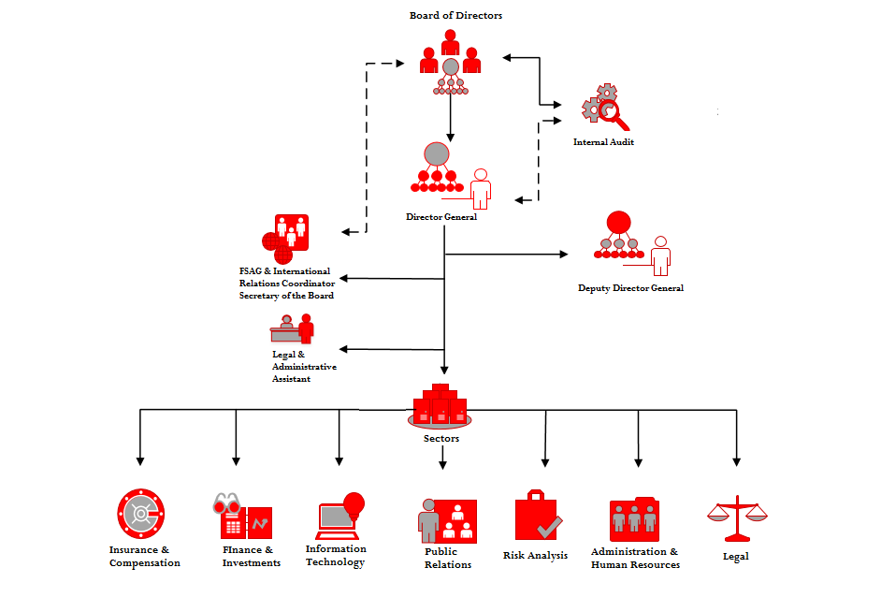

Graph 28. Structural composition according to functions

5.2.1. Professional qualification and internal audit
The Agency considers its human resources as one of the key factors in successfully achieving its objectives.
Human resource management in the Agency is oriented towards identifying the needs of the staff, improving their professional skills through trainings in line with their professional needs, in order to cope with various challenges in the future, correctly managing the files of the staff and the annual job performance evaluation for each employee, on due time and in accordance with the respective administrative rules.
The organizational chart of the Agency includes the relevant structure for the development of human resources, responsible for the organization, management and development of human resources in accordance with the objectives of the Agency.
The human resource development process is considered as one of the most important components to achieve the institutional goals and a key factor in achieving success. Throughout this year, the Agency has continued its work to enable continuous training of its staff as well as the development of incentive policies aimed at enhancing the professional qualifications of the staff in line with its mission and strategic objectives. During 2017, the staff attended training programs both at home and abroad. These trainings aimed at developing the skills necessary to exercise the respective functions in the framework of the policies of the Agency on the development of cooperation with international institutions and organizations, and exchanging experiences and modern practices.
The activity of the Agency in 2017 was audited by PricewaterhouseCoopers (PWC), a member of PricewaterhouseCoopers International Limited, one of the four most important auditing companies in the world which offers professional services. The engagement of this subject guarantees the delivery of a quality service in accordance to the international standards in the field of internal audit.
In 2017, PricewaterhouseCoopers audited the Agency according to the legal and regulatory framework set out in the technical specifications and Annual Plan 2017, and the Strategic Plan 2017-2019 approved by the Board of Directors. The priority in implementing the audit program was the definition of procedures and controls necessary to reduce current and future risks that are generally considered as barriers to the daily activity of the Agency in meeting its key functions and implementing its approved strategic plans.

Section 6 - Annexes

Annex 1 – Recommendations and implementation level of the Resolution of the Albanian Parliament

Pursuant to Article 7, point 1 and 2, of Law No. 53/2014, dated 22/05/2014, "On Deposit Insurance", as amended, the Deposit Insurance Agency shall report to the Assembly of Albania for its annual activity. In fulfilling this legal obligation, in 2017, as every year, the Agency submitted to the Assembly of Albania the Annual Report on its activity for 2016.

In the absence of a Resolution of the Assembly of Albania on the annual activity of the Deposit Insurance Agency for 2016 and pursuant to Decision No. 49/2017 of the Assembly of Albania "On the establishment of a mechanism for a systematic monitoring of the follow-up and implementation of recommendations issued to independent constitutional and law-based institutions", and the 6-month Action Plan on its implementation, the following table indicates the implementation of the recommendations of the Resolution adopted by the Assembly in 2016 on the annual activity of the Agency in 2015, reflecting also the actions undertaken by the Agency.

The recommendations of the Resolution of the Assembly of Albania on the activity of the Deposit Insurance Agency in 2015 and the concrete actions taken from the Agency in view of their implementation.
R1 | Further development of the deposit insurance scheme, identify potential areas for improvement in order to increase effectiveness and readiness in case of an insurance event
 | Pursuant to this recommendation and in accordance with the recommendations of the World Bank in the framework of the Action Plan for the implementation of the development policy for the modernization of the financial sector, the Agency proposed a legal initiative on inclusion of deposits of traders and companies to the deposit insurance scheme. The legal initiative was finalized with the approval by the Assembly of the Republic of Albania of Law No. 39/2016 "On some amendments and additions to Law No. 53/2014, dated 22/05/2014, "On Deposit Insurance". The adoption of this law enabled the increase of the base of depositors protected by the deposit insurance scheme, contributing to the strengthening of the financial stability in the Republic of Albania. Also, the law sets out the legal deadlines for inclusion into the scheme of the Savings and Credit Associations in order to coordinate the process with the restructuring of these subjects. The accession to the scheme of the Savings and Credits Associations as well as the inclusion of the deposits of traders and companies as insured deposits entered into force concurrently on 1st January 2017. Following the entry into force of Law No. 39/2016 "On some amendments and additions to Law No. 53/2014, dated 22/05/2014, "On Deposit Insurance", the focus of the work of the Agency has been to review the by-legal framework in force which regulates the deposit insurance activity of subjects member of the scheme, as well as improve the internal regulatory framework regarding the operational readiness of the Agency in case of an insurance event. To this end, the following by-legal acts have been adopted:
 | 1. Guideline No. 4187, dated 01/09/2016, of the Bank of Albania "On some additions and amendments to Guideline No. 3241, dated 18/12/2014 "On Deposit Insurance in Banks". The Guideline aims to reflect the legal amendments to the deposit insurance scheme, particularly with regard to the insurance of deposits of traders and companies in banks member of the scheme.
 | 2. Guideline No. 4188, dated 01/09/2016, of the Bank of Albania "On Deposit Insurance in Savings and Credit Associations". The Guideline regulates the terms and procedures for the membership of Savings and Credit Associations to the scheme, their relationship with the Agency, as well as the regulatory requirements for the insurance of deposit in these subjects.
 | 3. Decision No. 26, dated 17/10/2016, of the Board of Directors of the Deposit Insurance Agency "On the adoption of the data standard format for banks and Savings and Credit Associations". The decision defines the standard format of data reported by subjects member of the scheme to the IT System for Reporting and Compensation of the Deposit Insurance Agency (IT System).
 | 4. Regulation "On compensation of insured deposits", approved by Order No. 3762, dated 18/7/2016, of the Governor of the Bank of Albania. Its purpose is to detail the rules and procedures to carry out the compensation process, the selection of the agent bank and supporting subjects, as well as the interaction among subjects involved in the process.
R2 | Assist the preparation process of the Savings and Credit Associations to fulfil the required criteria, with a view to their simultaneous inclusion to the deposit insurance scheme. Disclose information about the Savings and Credit Associations on the website of the Agency.
 | 1. Pursuant to Law No. 39/2016, "On some amendments and additions to Law No. 53/14, dated 22/05/2014, "On Deposit Insurance", and in accordance with the recommendation of the Assembly of Albanian, following the publication in the Official Gazette of Law No. 39/2016 "On some amendments and additions to Law No. 53/14, dated 22/05/2014, "On Deposit Insurance", the Deposit Insurance Agency organized informative meetings with representatives of Savings and Credit Associations to clarify the requirements and legal deadlines for membership to the deposit insurance scheme, based on the relevant amendments.
 | 2. The Agency was seriously committed to assist all the Savings and Credit Associations licensed by the Bank of Albania to submit a request for membership to the deposit insurance scheme. In the informational meeting organized for this purpose, the Agency specifically explained two main issues: submission of the application for membership within the legal deadline - 31 May 2016 – and the correct manner of completing the accompanying documentation of application. In this meeting, the Agency also informed the representatives of the Savings and Credit Associations about the stages SCAs should go through to become members of the deposit insurance scheme.
 | 3. The Agency, in close co-operation with the Bank of Albania, conducted the first round of verifications in all Savings and Credit Associations that had submitted their applications for membership to the scheme. The verification reports issued recommendations to improve the work required to meet the membership criteria.
 | 4. After the first round of verifications, the Agency conducted meetings with all the Savings and Credit Associations that had submitted their applications for membership to the scheme, in view of possible uncertainties regarding the correction of findings and fulfilment of recommendations issued in the verification reports, in order to meet the membership criteria, accurately and timely.
 | 5. The final phase, prior to the decision-making of the Board of Directors of the Agency to accept or reject the application for membership to the deposit insurance scheme, was the second round of verifications in all Savings and Credit Associations. In this phase, the Agency verified the fulfilment of all terms, shortcomings and remarks, notifying the SCAs that had met the legal and by-legal criteria for the deposit insurance of the fulfilled criteria and their obligation to pay the initial contribution.
 | 6. The Agency uploaded the information on the Savings and Credit Associations on its online page.

R3 | Constantly improve the IT infrastructure for prompt and accurate payment of depositors in case of an insurance event, in order to safeguard the financial stability of the country
 | 1. Following the adoption of Law No. 39/2016, "On some amendments and additions to Law No. 53/2014, "On Deposit Insurance", on the inclusion of traders and companies to the eligible deposits, starting from 1st January 2017, the IT System for Reporting and Compensation (IT SYstem) was adapted to the electronic reporting of data. Data on the deposits of traders and companies are reported by banks and / or Savings and Credit Associations for the calculation of premiums and the prompt and accurate pay-out of depositors in case of an insurance event.
R4 | Engage in the efficient management of financial assets, find alternative ways of investment in circumstances when the rates of Government’s securities are declining, with a view to optimize and further expand the deposit insurance funds, in accordance with the principles of liquidity and security
 | 1. In order to increase the efficiency of the administration of the financial assets, the Regulation "On the administration of the financial assets of the Deposit Insurance Agency" was adopted. The novelties of this Regulation include, inter alia: a clear separation between enforcement and monitoring functions; reviewing and extending the functions of the Investment Committee; adapting the Financial Assets Management Strategy in accordance to the risk assessments for member subjects; as well as structuring the portfolio in tranches in order to respect the principles of liquidity and security.
 | 2. Investment alternatives, beyond those of the Albanian Government, have resulted to be almost corrosive for the funds. They are associated with additional costs for the investment process, while the return rates are extremely low for securities with a high level of safety. As a result, the Agency has diversified the portfolio by increasing the maturity of the Albanian Government’s securities while aiming at a proportional distribution among maturities.

R5 | Be attentive to developments in the banking and financial system in the country, maximize capacities to respond to potential situations that would require the intervention of the Agency.
 | 1. The Deposit Insurance Agency has established regular reporting lines with the member subjects and the Bank of Albania, establishing an adequate database for the assessment of risks in the banking system. The Agency uses a statistical methodology for these data and has established its early warning system under the rights provided by the law in this regard.
 | 2. The conduct of simulations with the Deposit Insurance Fund of Kosovo, the adoption of regulatory compensation acts and the conclusion of agreements with three agent banks which will carry out the distribution of payments to depositors in a very short time, are concrete steps towards strengthening the capacities of the Agency in terms of its legal objectives.
 | 3. The adoption of the Resolution Law creates more protection for depositors in case of an unpleasant situation in the banking system.
R6 | Constantly promote the deposit insurance scheme. Increase the level of education and awareness among depositors on the benefits and limitations of the deposit insurance scheme, as well as their acquaintance with the compensation procedure
 | 1. The Public Awareness Strategy document has been drafted.
 | 2. Trainings have been conducted with employees of banks and Savings and Credit Associations.
 | 3. The official website of the Deposit Insurance Agency has been updated and enriched with information.
 | 4. The profile of the Deposit Insurance Agency in its social networks has been enriched with information.
 | 5. Open lectures have been conducted with university students.
 | 6. In cooperation with the Bank of Albania and the Albanian Association of Banks we have participated in various activities in the framework of financial education campaigns.
 | 7. We designed and produced promotional leaflets for the Deposit Insurance Agency and distributed them free of charge to banks and Savings and Credit Associations.

Annex 2 – Financial Statements
Financial position statement
(All values are in ALL, unless otherwise specified)
 | On 31 December 2017 |  | On 31 December 2016
ACTIVES
Monetary assets and their equivalents | 3,857,238,311 |  | 3,141,657,507
Receivable insurance premiums | - |  | -
Investments held to maturity | 31,187,189,202 |  | 28,097,835,242
Assets and equipment, net | 60,379,348 |  | 66,130,831
Non-material long-term actives, net | 12,454,057 |  | 26,183,991
Other actives, net | 2,465,585 |  | 2,187,193
TOTAL ACTIVES | 35,119,726,503 |  | 31,333,994,764
LIABILITIES
Other liabilities | 10,416,180 |  | 10,178,587
TOTAL LIABILITIES | 10,416,180 |  | 10,178,587
DEPOSIT INSURANCE FUND
Start-up fund for deposit insurance in banks | 400,000,000 |  | 400,000,000
Start-up fund for deposit insurance in SCAs | 76,000,000 |  | 76,000,000
Accumulated fund for deposit insurance in banks | 34,617,089,962 |  | 30,843,190,622
Accumulated fund for deposit insurance in SCAs | 16,220,361 |  | 4,625,555
TOTAL FUND OF DEPOSIT INSURANCE | 35,109,310,323 |  | 31,323,816,177
TOTAL OF LIABILITIES AND DEPOSIT INSURANCE FUND | 35,119,726,503 |  | 31,333,994,764

Summarized income statement
(All values are in ALL, unless otherwise specified)
 | Year closed on  31 December 2017 |  | Year closed on  31 December 2016
Operating income:
Income from insurance premiums | 3,218,113,171 |  | 2,993,277,385
Income from initial contributions | 1,171,728 |  | 2,752,631
Income from interests | 781,534,888 |  | 783,367,869
Other operating income | 1,566,157 |  | 1,771,710
 | 4,002,385,944 |  | 3,781,169,595
Financial Expenses:
(Loss)/Profit from exchange to foreign currency | (60,364,693) |  | (15,276,911)
Other financial expenses | (34,143,110) |  | (58,835,416)
 | (94,507,802) |  | (74,112,327)
Operative expenses:
Staff expenses | (72,755,740) |  | (70,014,111)
Administrative expenses | (29,670,063) |  | (25,784,499)
Amortization expenses | (19,958,193) |  | (31,958,504)
 | (122,383,996) |  | (127,757,114)
NET SURPLUS FOR THE YEAR | 3,785,494,146 |  | 3,579,300,154
Other summarized income | - |  | -
TOTAL OF SUMMARIZED INCOME | 3,785,494,146 |  | 3,579,300,154

Statement of the inflow of assets
(All values are in ALL, unless otherwise specified)
 | Year closed on 31 December 2017 |  | Year closed on 31 December 2016
Surplus of funds | 3,785,494,146 |  | 3,579,300,154
Adjustments for:
Amortization | 19,263,193 |  | 31,958,504
Calculated Interest for investments in securities | (45,306,701) |  | (261,694,132)
Changes to:
Receivable insurance premiums | - |  | -
Other actives | (278,392) |  | 83,551
Other liabilities | 237,593 |  | (3,722,860)
Inflow of monetary assets generated from the operational activity | 3,759,409,840 |  | 3,345,925,217
INVESTING ACTIVITY
Purchase of equipment | 218,224 |  | (179,994)
Purchase of non-material long-term actives | - |  | (11,751,575)
Purchase of securities | (3,044,047,260) |  | (1,945,273,920)
Inflow of monetary assets used in investing activity | (3,043,829,036) |  | (1,957,205,489)
Net increase/ (decrease) of monetary assets during the year | 715,580,804 |  | 1,388,719,728
Monetary assets and their equivalents at the beginning of the year | 3,141,657,507 |  | 1,752,937,779
Monetary assets and their equivalents at the end of the year | 3,857,238,311 |  | 3,141,657,507

Statement of changes to the deposit insurance fund
(All values are in ALL, unless otherwise specified)

 | Start-up capital for deposit insurance in banks | Start-up capital for deposit insurance in Savings and Credit Associations | Accumulated fund for deposit insurance in banks | Accumulated fund for deposit insurance in Savings and Credit Associations | Total
On 31 December 2015 | 400,000,000 | 76,000,000 | 27,267,345,685 | 1,170,337 | 27,744,516,022
Changes to the start-up capital | - | - | - | - | -
Total of summarized income for the year | - | - | 3,575,844,937 | 3,455,218 | 3,579,300,155
On 31 December 2016 | 400,000,000 | 76,000,000 | 30,843,190,622 | 4,625,555 | 31,323,816,177
Changes to the start-up capital | - | - | - | - | -
Total of summarized income for the year | - | - | 3,773,899,340 | 11,594,806 | 3,785,494,146
On 31 December 2017 | 400,000,000 | 76,000,000 | 34,617,089,962 | 16,220,361 | 35,109,310,323

The total number of depositors was determined by collecting aggregated data reported by each bank; therefore persons holding deposits in several banks were registered several times. This figure also includes depositors with a zero balance in their deposits.
In office since February 2017.

